This paper illustrates exactly the problems with the evidence concerning homeopathy discussed in the CVMA white paper. Low-quality studies with poor control for bias, confounding, and other sources of error are cited to justify claims that the evidence does not support. Sometimes, even studies which find no effect are cited to support claims of an effect. Bits of legitimate science are misinterpreted to generate the false impression that they validate the implausible theoretical foundations of homeopathy. Clear publication bias in support of homeopathy is ignored whereas negative evidence is dismissed on the basis of presumed individual bias regardless of the methodological controls used to account for this. This document is exactly what the authors claim the CVMA white paper to be; an attempt to select and distort the evidence in favor of their pre-exiting beliefs. Thoughtful individuals who wish to determine the truth of the matter should read both documents thoroughly and carefully and decide which is more consistent with the spirit and methods of science, and with the facts.
Though it is tedious, a thorough examination of the claims and the evidence presented in this paper clearly shows that the conclusions of the CVMA white paper, that homeopathy is implausible and has been shown by a preponderance of the evidence to be ineffective, remain accurate.
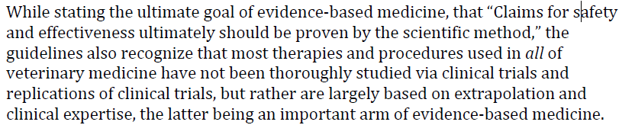
This amounts to the claim that homeopathy is no less supported by scientific evidence than most conventional therapies. This is complete nonsense. While there is certainly a need for more and better evidence in many areas of medicine, homeopathy has convincingly failed to be supported at any level, from basic plausibility and consistency with established knowledge through in vitro and other preclinical research all the way to the level of systematic reviews of clinical trials. The same claim has been made in human medicine and it has been clearly shown that conventional medical therapies are supported by good evidence to a much greater degree than alternative therapies, particularly homeopathy.
For example, a survey of the literature shows that in the following areas of conventional medicine, the majority of practices are based on compelling scientific evidence:
96.7% of anesthetic interventions (32% by RCT, UK)
approximately 77% of dermatologic out-patient therapy (38% by RCT, Denmark)
64.8% of 'major therapeutic interventions' in an internal medicine clinic (57% by RCT, Canada)
95% of surgical interventions in one practice (24% by RCT, UK)
77% of pediatric surgical interventions (11% by RCT, UK)
65% of psychiatric interventions (65% by RCT, UK)
81% of interventions in general practice (25.5% by RCT, UK)
82% of general medical interventions (53% by RCT, UK)
55% of general practice interventions (38% by RCT, Spain)
78% of laparoscopic procedures (50% by RCT, France)
45% of primary hematology-oncology interventions (24% by RCT, USA)
84% of internal medicine interventions (50% by RCT, Sweden)
97% of pediatric surgical interventions (26% by RCT, UK)
70% of primary therapeutic decisions in a clinical hematology practice (22% by RCT, UK)
72.5% of interventions in a community pediatric practice (39.9% by RCT, UK)
Thus, published results show an average of 37.02% of interventions are supported by RCT (median = 38%). They show an average of 76% of interventions are supported by some form of compelling evidence (median = 78%). (Imrie, R. Ramey, D. The evidence for evidence-based medicine. Complementary Therapies in Medicine (2000), 8, 123-126.)
The “proving” is not a legitimate form of scientific evidence. The claim that a given substance causes certain symptoms in healthy people is based entirely on giving it to subjects and then looking at what they experience afterwards and guessing which experiences are due to the substance.

The unreliability of this method was recognized early on by critics of homeopathy. In his lectures Homeopathy and Its Kindred Delusions, given in 1842, Oliver Wendell Holmes discussed some examples of homeopathic provings to make this point.

“The following list [of symptoms] was taken literally from the Materia Medica of Hahnemann…

‘After stooping some time, sense of painful weight about the head upon resuming the erect posture.’
‘An itching, tickling sensation at the outer edge of the palm of the left hand, which obliges the person to scratch.’
The medicine was acetate of lime, and as the action of the globule taken is said to last twenty-eight days, you may judge how many such symptoms as the last might be supposed to happen…
I have not cited these specimens with any view to exciting a sense of the ridiculous, which many others of those mentioned would not fail to do, but to show that the common accidents of sensation, the little bodily inconveniences to which all of us are subject, are seriously and systematically ascribed to whatever medicine may have been exhibited, even in the minute doses I have mentioned, whole days or weeks previously.
To these are added all the symptoms ever said by anybody, whether deserving confidence or not….”

Attempts to repeat some of the proving Hahnemann reported, by giving homeopathic remedies to healthy people, have not shown that these remedies can elicit consistent, or even detectable, symptoms.( Sarah Brien, George Lewith, and Trevor Bryant. (Ultramolecular homeopathy has no observable clinical effects. A randomized, double-blind, placebo-controlled proving trial of Belladonna 30C. Br J Clin Pharmacol. 2003 November; 56(5): 562–568.)
There is poor consistency between homeopaths in how such “trials” are interpreted. (Brien S, Prescott P, Owen D, Lewith G. How do homeopaths make decisions? An exploratory study of inter-rater reliability and intuition in the decision making process. Homeopathy. 2004 Jul;93(3):125-31.)
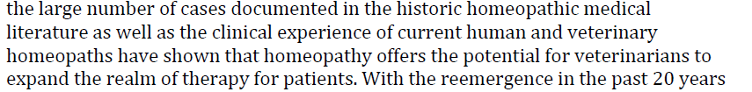
Case reports can only identify potential hypotheses to test formally. They do not provide evidence to confirm or disconfirm a hypothesis. In the case of homeopathy, there is abundant research evidence (as identified in the CVMA white paper) showing that it is ineffective. There are also many recorded anecdotes supporting blood-letting, astrology, psychic phenomena, and many other modalities clearly understood to be ineffective based on scientific investigation. The fact that people believe in this approach and then report anecdotes that support that belief is not compelling evidence the belief is true.
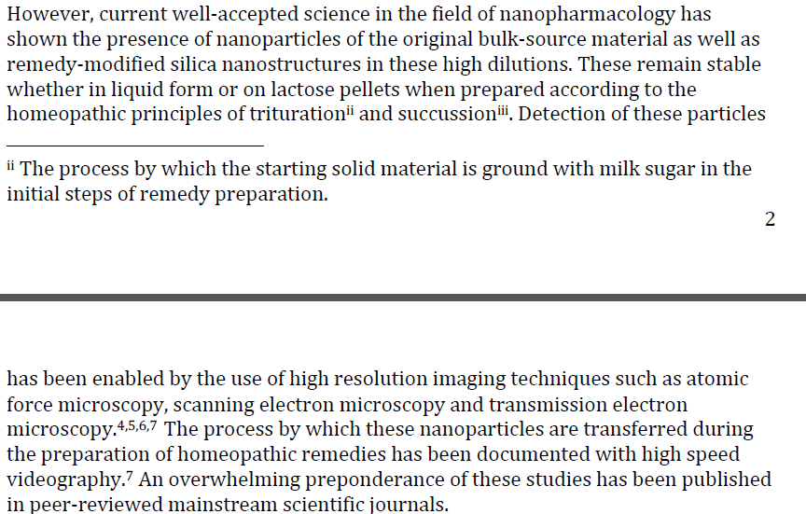
There is nothing well-accepted about the “nanoparticle” theory of homeopathy in either mainstream science or even among homeopaths. (http://dialecticalhomeopathy.com/2012/08/27/homeopathy-is-nanomedicine-irrational/ and http://dialecticalhomeopathy.com/2011/09/25/did-the-nano-particle-theory-anyway-explain-similia-similibus-curentur/). This is simply an attempt to hijack the legitimate nascent field of nanoparticle physics to create the illusion of a coherent, plausible theoretical foundation for homeopathy.
The papers cited to support this claim contain poor controls for bias and contamination of materials tested. They use a variety of imaging methods to detect unidentified “nanoparticles” in substances. Whether these particles have anything at all to do with the starting material, the process of preparation, the containers in which they are prepared, or any of the claimed biological effects of homeopathic remedies (which have failed to be substantiated in numerous studies) is not addressed. Undoubtedly, nanoparticles exist in virtually any drop of water. Finding them in water claimed to be a homeopathic remedy does not validate the theory or clinical effects of homeopathy.
And the presence of such nanoparticles in homeopathic remedies and in plain water doesn’t answer the question of how such particles could exert a specific, healing effect according to the Law of Similars as dictated by the intuition and subjective “proving” process. It also doesn’t answer how a biological effect due to nanoparticles could be absolutely beneficial with no possible side effects, as is often claimed by homeopaths when identifying their remedies as safer than conventional medicines.
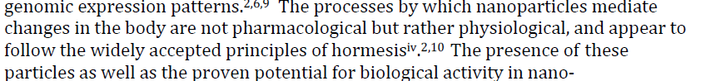
The first part of this statement, that nanoparticles exert effects by a mechanism that is “not pharmacological but rather physiological” is meaningless. The intent is apparently to excuse the inability of research in homeopathy to demonstrate a dose-response relationship between remedies and biological effects as somehow representing a novel mechanism of action, rather than the absence of a specific biological effect. While nanoparticles in general do have biological effects, this does not demonstrate that homeopathic remedies 1) contain predictable quantities of nanoparticles derived from the starting material, 2) that these remedies have biological effects attributable to the particles they contain, and 3) that these effects are specific, predictable, and beneficial. Existing evidence shows these claims not to be true, and identifying nanoparticle sin homeopathic remedies in dubious laboratory studies does not alter this.
As for the reference to hormesis, this is another attempt to hijack a puzzling phenomenon observed in conventional science and make it appear to be a sound theoretical explanation for the claimed effects of homeopathic treatment.
In brief, hormesis is the notion that a high dose of radiation or a toxin may generate the opposite response as a low dose. Some authors have suggested a broader definition, in which any potentially harmful stimulus which generates an adaptive response is considered an example of hormesis.
The notion is controversial in that while such a dose response relationship in laboratory settings can be shown for a variety of toxins, it is not clear that this represents a phenomenon with therapeutic potential. Extensive research on the concept of hormesis applied to radiation, for example, has generated little convincing evidence (http://www.sciencebasedmedicine.org/index.php/ann-coulter-says-radiation-is-good-for-you-2/) to support claims that low doses of radiation can have beneficial health effects. While organisms may be able to compensate for injurious stimuli at low levels, and generate some defense against these stimuli, this response has not been shown to be a general mechanism for protecting organisms, and it is possible that such low-level stressors may actually be harmful over time.
However, even if hormesis turns out to have some true therapeutic potential, it doesn’t support the clinical claims of homeopathy. The low doses of toxins in studies on hormesis are at least measurable doses, unlike the complete absence of any “material substance” in most homeopathic preparations.
Another problem is that the relationship between specific substances and the symptoms they are used to treat is only based on the subjective and unsystematic observations of “provings,” so even if solutions that had once contained some of these substances could somehow have medicinal effects, we don’t have a consistent and reliable way to select specific remedies for specific problems, just homeopathic intuition.
And finally, the symptoms a patient reports and the process by which the homeopath decides which are important and which aren’t and which remedies to use are thoroughly subjective and inconsistent (Brien S, Prescott P, Owen D, Lewith G. How do homeopaths make decisions? An exploratory study of inter-rater reliability and intuition in the decision making process. Homeopathy. 2004 Jul;93(3):125-31.)
So while hormesis is an interesting phenomenon worthy of study, it is not a widely accepted or established validation of the theory behind homeopathy.
This is simply untrue. As the CVMA white paper showed, the majority of studies purporting to support homeopathy are published in journals devoted to homeopathy or other forms of alternative medicine. Studies published in mainstream journals are far more likely to report negative results.
There is ample evidence for a publication bias in homeopathy journals and other journals devoted to alternative medicine. In 1995, only 1% of studies published in alternative medicine journals reported negative results, and in 2001 95% of such studies reported positive results (Schmidt, K., Pittler, M.H., Ernst, E., (2001a) A profile of journals of complementary and alternative medicine Swiss Med Weekly Vol. 131 pp. 588-591; Schmidt, K., Pittler, M.H., Ernst, E., (2001b) Bias in alternative medicine is still rife but is diminishing British Medical Journal Vol. 323 no. 7320 p. 1071)

A study published in 2005 (in an alternative medicine journal) found that 69% of homeopathy studies in mainstream journals reported negative results whereas only 30% of studies in alternative journals reported a negative result. (Caulfield, T., and DeBow, S., 2005 A systematic review of how homeopathy is represented in conventional and CAM peer reviewed journals BMC Complementary and Alternative Medicine Vol. 5 no. 12)

Of the 16 veterinary studies listed in the CVMA white paper that reported positive results, 11 were published in journals dedicated to homeopathy or alternative medicine. Of the 15 veterinary studies listed in the CVMA white paper that reported negative results, only 2 were published in such alternative journals.
A majority of the citations in this AVH white paper are also from homeopathy and alternative medicine journals. Of those published in mainstream journals, many do not support the efficacy of homeopathy:
Ref. 8 did not evaluate homeopathic remedies or treatment
Ref. 9 did not evaluate homeopathic remedies or treatment
Ref. 12 was apparently a duplication of a report published earlier in a homeopathy journal
Ref. 18 was later found to be erroneous by an investigation organized by the journal
Ref. 24 was disavowed by one of its own authors
Ref. 29 was a case report
Ref. 30 was heavily criticized for poor methodology, so the author conducted a much larger trial of the same treatment for the same indication, and this trial found no treatment effect
Ref. 32 contained an assessment of one systematic review of homeopathy. That review looked at 4 trials and concluded “the effectiveness of homoeopathy as a symptomatic treatment for FM remains unproven.”
Ref. 42 actually reported a negative result not supportive of homeopathy. “We were unable to distinguish between Belladonna C30 and placebo using our primary outcome measure. This pilot study does not demonstrate a clear proving reaction for Belladonna C30 versus placebo”
Ref. 46 also reported a negative result not supportive of homeopathy. “Evidence of efficacy of homeopathic treatment beyond placebo was not found in this study…”
Ref. 48 did not evaluate a homeopathic remedy or homeopathic treatment.
Ref. 53 concluded “The database on studies of homeopathy and placebo in psychiatry is very limited, but results do not preclude the possibility of some benefit.”

Overall, it is clear that much of the supposedly positive research evidence for homeopathy is at high risk of bias and published in journals with an a priori bias in favor of alternative therapies.
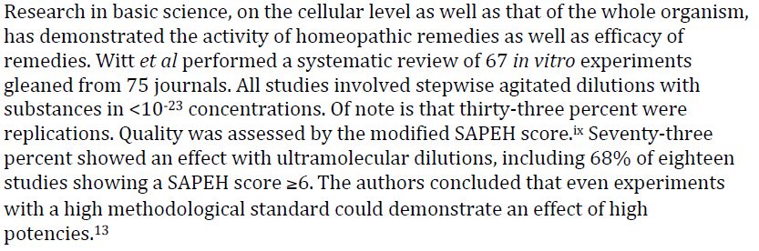
Actually, only 46 of the publications reviewed were journal articles, and about half (25) of these were in homeopathy or alternative medicine journals. Only 18% of the studies reported randomization and only 33% reported blinding, illustrating the poor control for bias in many of these studies. Only 31% of studies reported sucussed controls. Only 18 of the 67 experiments met the quite generous minimum score for quality control, and of these only 18% reported successful replication.
This paper confirms the statements in the CVMA white paper that the higher the quality the less likely a positive result will be reported. The authors even acknowledge that, “Publication
Bias…is very likely in the field of homeopathy [and] would cause a tendency to positive results. For example, unsuccessful pilot studies in search for a viable test system may not have been published.”

These are pretty lackluster results, especially given that the paper was published in an alternative medicine journal (which even the authors acknowledge increases the influence of publication bias) and was funded by a foundation specifically set up to support alternative medicine research. If this is the best that can be found, even with clear bias, to suggest there is meaningful in vitro research supporting the claims made for homeopathy, then the case is weak indeed.
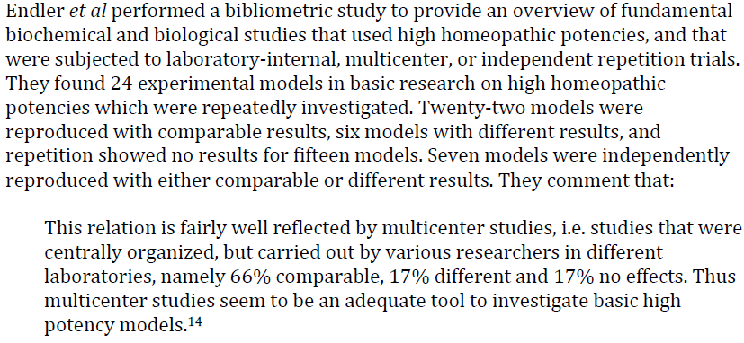
This was not a systematic review but a review in which the authors identified and selected studies to include without explicit, replicable methods fixed in advance. This increases the influence of selection bias in a review. And many sources of study reports other than peer-reviewed journals were accepted. No effort was made to identify or control for publication or selection bias. And once again, this review was published in a dedicated homeopathy journal and funded by a foundation dedicated to the promotion of alternative medicine. The lack of control for bias is a serious limitation for this review.
Wide latitude was given to what was considered a “replication,” so similar experiments not actually involving the same remedies or ingredients were often counted as replications. And studies were included without any meaningful statistical analysis if they were published before 1940. The authors acknowledge the low quality standards for included studies; “One will agree that these standards are not too high, i.e. that we are not referring to “Gold Standard” publications only.”
Despite the obvious intent and effort on the part of the authors to dig up evidence supportive of homeopathy, they were forced to admit, “However, when comparing the studies in detail one must conclude that no independent repetition trial yielded exactly the same results as the initial study, and methods always differed to a smaller or larger extent.”
And after all these opportunities to select and evaluate studies in a way that supported their pre-existing beliefs, the authors reported that, “When all repetitive (but not initial) studies are considered, 69% report an effect comparable to that of the initial study, 10% a different effect, and 21% no effect.” However, “when only the independent replication studies are taken into account,” the numbers drop to “44% comparable, 17% different, and 39% no effect.”) These “independent” replications are still , of course, carried out by believers in homeopathy and, in many cases, published in dedicated alternative medicine journals, but they show far lower rates of “success” at replicating initial results. This is not suggestive of a clear underlying phenomenon consistently identified in multiple studies but of the influence of bias and poor methodology on the outcome of research studies. Again, if this is the best that can be said of in vitro homeopathy research, it is far less compelling that the results expected, and obtained, for conventional medical therapies.
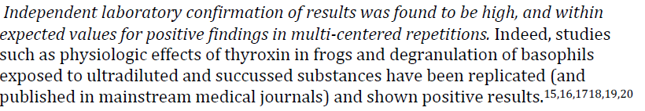
Four out of the six studies cited here have been published in alternative medicine or homeopathy journals. They generally do not consist of “independent” replications since they concern different research models and three of the six were performed one group. This group reported inconsistent effects for subjectively measured outcomes. They even reported treatment effects when the homeopathic solution wasn’t used but instead an audio recording of the solution was played to the frogs or the solution was placed near the animals in a sealed container. Apart from being highly implausible and inconsistent with established principles of physiology, this finding would contradict the very theories about nanoparticles put forward in this document to supposedly explain how homeopathy could work.

One of those two published in a mainstream journal (Nature, Ref. 18) was subsequently identified as erroneous by an investigative team put together by the editors of this journal. This team found that the results had been generated by an unblinded technician, and when this individual was unaware of the treatment given to each sample, the positive findings disappeared.( Maddox, J. Randi, J. Stewart, W. "High-dilution" experiments a delusion. Nature1988;334:287-290.)

Subsequently, multiple attempts by independent researchers to replicate the original experiment also failed to find an effect.( Ovelgonne, J.H.; Bol, A.W.; Hop, W.C.; Van Wijk, R. Mechanical agitation of very dilute antiserum against IgE has no effect on basophil straining properties. Experientia 1992;48(5):504–8. and Hirst, S.J.; Hayes, N.A.; Burridge, J.; Pearce, F.L.; Foreman, J.C. Human basophil degranulation is not triggered by very dilute antiserum against human IgE. Nature 1993;366(6455):527.)

A review published in a homeopathy journal in 2009 concluded that after twenty years of research, it was still impossible to determine conclusively that purported effects of ultradilute solutions on human basophils were not due solely to artifact.( Ennis, M. Basophil models of homeopathy: a sceptical view. Homeopathy 2010;99(1):51–56.)

So once again the studies cited to support the notion that consistent, predictable, significant, and replicated evidence for biological effects of homeopathic preparations exists turns out, when closely examined, to be untrue.
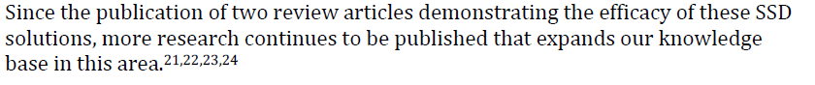
These references do not support the claims that homeopathic remedies have real effects. Despite most being conducted by believers in homeopathy, funded by institutions dedicated to promoting alternative medicine, and published in alternative journals, all but one of these studies fail to show consistent, significant, biologically meaningful results. One actually investigated a plant extract and has nothing at all to do with homeopathy. Another, one published in a mainstream journal, was so misleading and methodologically poor that one of the authors has publically disavowed the study.
Case reports and case series make up the bulk of the evidence for homeopathy because they are uncontrolled anecdotes in which an ineffective therapy can easily appear effective due to spontaneous remission, regression to the mean, placebo effects, bias, and other sources of error. Such anecdotes exist to support the effectiveness of blood-letting, faith healing, and every other medical intervention ever invented. Either everything one of these therapies is effective, or anecdotes are not sufficient to validate a medical therapy. While case reports are appropriate to suggest hypotheses that merit further investigation, they cannot be used to prove or disprove such hypotheses. This is why controlled, formal research is necessary.
Given the 200 years since the invention of homeopathy, and the failure of controlled research to demonstrate the biologic plausibility or clinical effectiveness of the approach, case reports are insufficient to demonstrate the safety or efficacy of homeopathy. In this context, this is a meaningless type of evidence which serves only to illustrate how weak the evidence base for the practice really is.
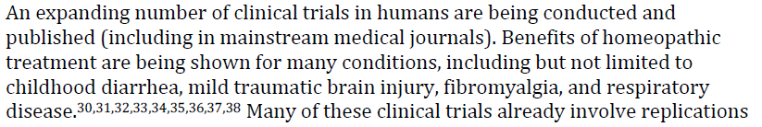
The biased selection of individual trials that report a positive result, while ignoring those which fail to show an effect, is a misleading tactic commonly used to defend homeopathy. The gold standard for evaluating the balance of the clinical trial evidence for any therapy is the systematic review, which identifies and evaluates all clinical trials and ranks them according to quality of design and conduct. This allows an accurate assessment of the preponderance of the evidence.
In the case of homeopathy, such reviews have been conducted, and in the words of the House of Commons Science and Technology Committee, “the systematic reviews and meta-analyses conclusively demonstrate that homeopathic products perform no better than placebos. We could find no support from independent experts for the idea that there is good evidence for the efficacy of homeopathy.”

Because there have been so many systematic reviews of clinical trials on homeopathic treatment,
there is even a systematic review of those reviews. This review evaluated all prior systematic
reviews and meta-analyses of homeopathy. According to the summary of this review:
“Eleven independent systematic reviews were located. Collectively they failed to provide strong evidence in favour of homeopathy. In particular, there was no condition which responds convincingly better to homeopathic treatment than to placebo or other control interventions. Similarly, there was no homeopathic remedy that was demonstrated to yield clinical effects that are convincingly different from placebo.

It is concluded that the best clinical evidence for homeopathy available to date does not warrant positive recommendations for its use in clinical practice.” (Ernst E. A systematic review of systematic reviews of homeopathy. British Journal of Clinical Pharmacology. 2002;54:577-582.)

Even if one ignores this and looks in detail at the trials cited here, one finds the evidence is not supportive of the claim that homeopathy is effective. Detailed evaluations of each reference cited are provided below, and they clearly show that the studies contain multiple serious flaws and limitations which undermine confidence in their results. Given the implausibility of homeopathy and the balance of the high-level evidence against it, such flawed evidence is not nearly sufficient to establish efficacy.
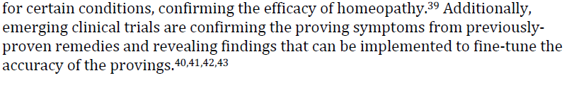
The CVMA white paper addressed the subject of provings. These are not a legitimate form of scientific study but a subjective reporting of symptoms used to judge, again by completely subjective criteria, what symptoms homeopathic remedies cause so that homeopaths can determine what symptoms they should be used to treat according to the Law of Similars. Seevral studies have attempted to verify that homeopathic remedies do cause symptoms in healthy volunteers and have not found any consistent effect:

Dantas F, Fisher P. A systematic review of homeopathic pathogenic trials (‘provings’)
published in the United Kingdom from 1945 to 1995. In: Ernst E, editor. Homeopathy: a
critical appraisal. London: Butterworth Heinemann; 1998. pp. 69–97.

Brien S, Prescott P, Owen D, Lewith G. How do homeopaths make decisions? An
exploratory study of inter-rater reliability and intuition in the decision making process.
Homeopathy. 2004 Jul;93(3):125-31.
Sarah Brien, George Lewith, and Trevor Bryant1. Ultramolecular homeopathy has no
observable clinical effects. A randomized, double-blind, placebo-controlled proving trial
of Belladonna 30C. British Journal of Clinical Pharmacology. 2003;56(5):562–568.

Walach H, Koster H, Hennig T, Haag G. Symptoms produced from homeopathic
Belladonna C30 are likely due to chance. Journal of Psychosomatic Research.
2001;50:155–160.
Interestingly, of the four studies cited here, three of them (Refs. 40, 42, 43) actually reported predominantly negative results and no clear difference between symptoms reported in volunteers receiving homeopathic remedies versus placebo. Though the authors try to interpret their findings in the most positive way possible, they do not actually report any clear effect suggesting that the proving process tells us anything about the purported effects of homeopathic preparations. It is puzzling why defenders of homeopathy would cite trials with negative results as support for their position, but it clearly indicates the evidence does not favor their claims.
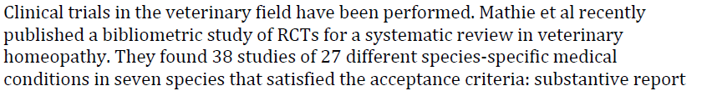
Clinical trials have been performed. Of the 38 studies identified in this review as suitable for inclusion in a systematic review, 25 were specifically evaluated in the CVMA white paper, and a number of additional studies were discussed not mentioned in Ref. 44. This contradicts the suggestion made earlier that important homeopathy literature was ignored in the CVMA review.
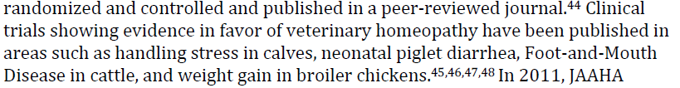
Again, a detailed examination of these references does not support their use in defense of homeopathy. One of them actually reports a negative result (Ref 46), and another doesn’t actually study a homeopathic remedies or treatment process (Ref 48). The other two find a few statistically significant differences out of many, many comparisons which show no difference and make no attempt to correct for conducting multiple comparisons, so these are more compatible with random error and bias than a real clinical effect. If this is the best clinical trial evidence veterinary homeopathy has to offer, it is far below the level that would justify any claim of efficacy.
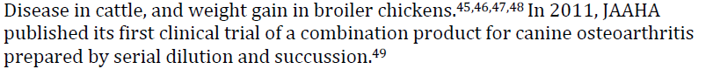
The authors admit in the paper that “this is not a classical homeopathic preparation,” since it is a mixture of many preparations some at low enough dilutions to potentially have pharmacological effects. A close analysis of the paper identifies a number of potential sources of error, and ultimately it is low-quality evidence not sufficient to contradict the preponderance of evidence against homeopathy.
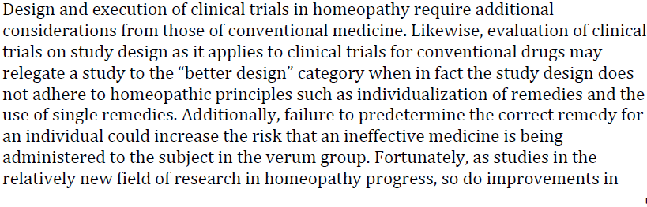
This is a form of special pleading, arguing that hoemopathy cannot always meet the standard criteria of evidence expected of conventional medicine and so we must change the way we evaluate our therapies to accommodate hoemopathy. This philosophical position, which exempts certain alternative therapies from the practices of evidence-based medicine, has been discussed previously (McKenzie, BA. Is complementary and alternative medicine compatible with evidence-based medicine? J Amer Vet Med Assoc. 2012;241(4):421-6.). If accepted, this argument effectively allows any method which is theoretically or philosophically incompatible with the tenets of mainstream science to claim it must be tested differently, and without the controls for chance, bias, and error that have made scientific medicine so successful. Such an approach fundamentally undermines the value of science as the foundation for veterinary medicine.
This is simply untrue. As the CVMA white paper discussed in detail, a review of the systematic reviews of homeopathy trials (Ernst E. A systematic review of systematic reviews of homeopathy. British Journal of Clinical Pharmacology. 2002;54:577-582.) identified 11 independent systematic reviews and 6 re-analyses of one of these. This review of reviews concluded that the 11 independent reviews,

“Collectively…failed to provide strong evidence in favour of homeopathy. In particular, there was no condition which responds convincingly better to homeopathic treatment than to placebo or other control interventions. Similarly, there was no homeopathic remedy that was demonstrated to yield clinical effects that are convincingly different from placebo.

It is concluded that the best clinical evidence for homeopathy available to date does not warrant positive recommendations for its use in clinical practice.”
As for the six re-analyses of the review that concluded homeopathy effects were not placebo effects, all found that this conclusion resulted from the inappropriate inclusion of exactly the kind of methodologically poor studies frequently cited in this document. Even the authors of the apparently positive review concluded,
“Studies that were explicitly randomized and were double-blind as well as studies scoring above the cut-points yielded significantly less positive results than studies not meeting the criteria. In the cumulative meta-analyses, there was a trend for increasing effect sizes when more studies with lower-quality scores were added…We conclude that in the study set investigated, there was clear evidence that studies with better methodological quality tended to yield less positive
results.”
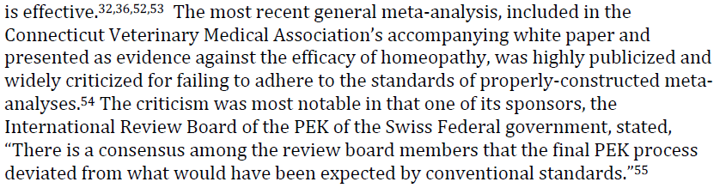
The criticism that is cited here (Ref. 55), simply claims that for political reasons the PEK reports were released before all members of the board had adequate time to comment on them and that political decisions about the funding of alternative therapies in Switzerland were made before the board had finalized its report. There is nowhere in this document any rejection of the contents of the meta-analysis cited in the CVMA white paper (ref. 54).
Homeopaths have, of course, been critical of this meta-anlaysis and attempted to show it does not, in fact, demonstrate that homeopathy is no more than a placebo (e.g. Peter Fisher Homeopathy and The Lancet. Evid Based Complement Alternat Med. 2006 March; 3(1): 145–147. Published online 2006 January 26. doi: 10.1093/ecam/nek007). One group of homeopaths has even gone so far as to re-analyze this meta-analysis (Ref. 54) to show that it would have reached different conclusions had different studies been included or excluded (Lüdtke R, Rutten AL. The conclusions on the effectiveness of homeopathy highly depend on the set of analyzed trials. J Clin Epidemiol. 2008 Dec;61(12):1197-204. doi: 10.1016/j.jclinepi.2008.06.015. Epub 2008 Oct 1.). However, the results of this re-analysis showed very little difference which subset of trials was included. A marginally significant effect could be demonstrated if enough low-quality studies were added, but overall the meta-analysis and meta-regression found the same lack of effect reported in the original meta-analysis. Despite an deliberate attempt refute the original meta-analysis, the best the authors could manage was to suggest its conclusions might not be as definitive as some have presented them;
“In our study, we performed a large number of meta-analyses and meta-regressions in 21 high quality trials comparing homeopathic medicines with placebo. In general, the overall ORs did not vary substantially according to which subset was analyzed, but P-values did….Our results do neither prove that homeopathic medicines are superior to placebo nor do they prove the opposite….Shang’s conclusions are not so definite as they have been reported and discussed.”
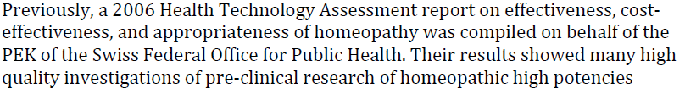
It is interesting that defenders choose to cite this review since it was produced by exactly the same group that produced the meta-analysis they try to discredit in the preceding paragraph, which was supposedly influenced by political considerations. Why the review which concluded homeopathy was ineffective should be unreliable and that which concluded homeopathy is effective should be accepted is unclear.
This review has been analyzed in detail and found to be a biased selection and evaluation of studies so clearly aimed at reaching the a priori conclusion that homeopathy is effective as to be almost unethical. One reviewer has described the report this way:
“This paper analyses the report and concludes that it is scientifically, logically and ethically flawed. Specifically, it contains no new evidence and misinterprets studies previously exposed as weak; creates a new standard of evidence designed to make homeopathy appear effective; and attempts to discredit randomised controlled trials as the gold standard of evidence. Most importantly, almost all the authors have conflicts of interest, despite their claim that none exist. If anything, the report proves that homeopaths are willing to distort evidence in order to support their beliefs, and its authors appear to have breached Swiss Academies of Arts and Sciences principles governing scientific integrity.

The present paper has established that the authors of this report adopted a very unusual strategy in what should have been an impartial evidence appraisal. It appears that their goal was not to provide an independent assessment but to choose criteria that would lead to their chosen conclusion that homeopathy is effective. To this end, they chose to adopt a highly questionable criterion of “real-world” effectiveness, ignore negative findings concerning homeopathy in favour of implausible reinterpretation of results, and attack RCTs. This use of a unique and suspect methodology in an appraisal designed to assess healthcare objectively gives cause for particular concern; one imagines that the Swiss government wanted homeopathy to be judged against existing standards rather than new ones created specially for the evaluation. In doing so the authors have distorted the evidence and misled the public; these actions, combined with their conflicts of interest, strongly suggest that they are guilty of research misconduct.”
(Shaw, DM. The Swiss report on homeopathy: a case study of research misconduct Swiss Med Wkly. 2012;142:w13594)
Another review concluded:
“ This brief, critical analysis of Homeopathy in Healthcare: Effectiveness, Appropriateness, Safety, Costs’ discloses this report as methodologically flawed, inaccurate and biased. Hence, its conclusions are not reliable.”
(Ernst, E. A critique of the Swiss report Homeopathy in Healthcare Focus on Alternative and Complementary Therapies Volume 17, Issue 3, pages 160–162, September 2012.)
A pre-requisite for a therapy being cost-effective is that it be effective. Neither of these references shows that homeopathy is effective or even attempts to do so. They are both surveys which ask people who seek alternative therapies if they are happy about having done so. Many are, but that says nothing about the effectiveness of these treatments. Thousands of people over many centuries were satisfied with the results of blood-letting, astrology, faith healing, and many other ineffective treatments. The notion that this serves as evidence of efficacy is a pre-scientific one which is incompatible with modern science and evidence-based medicine.
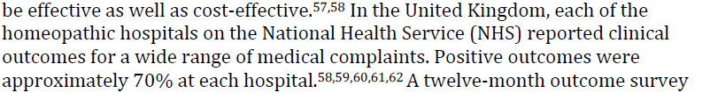
All of these references are surveys of patient satisfaction (and two of them, Refs. 57 and 59, refer to the same publication). None of them provide objective evidence that homeopathy is effective; they simply rely on the notion that if patients are happy the practice is justified. However, it is remains unethical to promote a placebo therapy as having real, objective, clinically meaningful effects when controlled research clearly demonstrates that it does not.
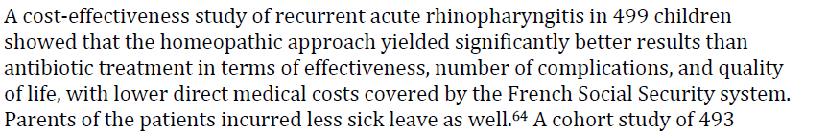
The authors of this study acknowledge in the report that the two groups differed in significant ways that could have generated the false appearance of a better outcome for those receiving homeopathic treatment:
“Another important limitation of this study concerns the comparability of the two samples of patients although they were generally similar, they differed with respect to passive smoking and childcare. The children followed by GPs of group A were more exposed to passive smoking, which is important as this is a factor that increases the risk of recurrent acute rhinopharyngitis.11 This non-homogeneity may have skewed the medical effectiveness results in favour of the patients of group H.”

And no differences were found in overall cost of treatment or in the rate of side effects. This is not compelling evidence for the cost-effectiveness of homeopathy.
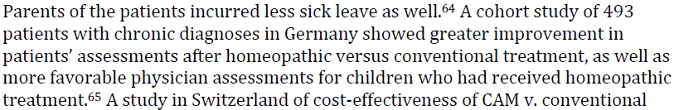
Yet another non-randomized, unblinded study with various and arbitrarily selected medical conditions and treatments and no control for chance, bias, or other sources of error. And despite the lack of such controls, most comparisons between groups showed no statistically significant differences. This is simply a largely unsuccessful attempt to confirm the pre-existing beliefs of the investigators by utilizing subjective outcome measures and no controls for bias.
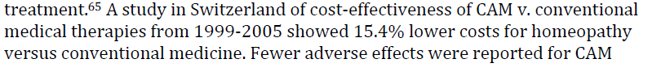
This survey of insurance data suggests that for a two-year period in Switzerland, the mandatory government health insurance carried by all citizens paid 15.4% more for those patients who treated by doctors who did not offer homeopathy than those who were treated by doctors who did. It also includes yet another uncontrolled patient satisfaction survey. None of this speaks to the question of whether or not homeopathy is effective, and given the lack of controls for bias and publication in a journal with a demonstrated bias in favor of homeopathy, it is not even reliable in terms of the relative costs of conventional and homeopathic treatment.
In this study, elderly patients in Germany and Switzerland was asked to rate their symptoms and quality of life when first presenting to a physician who practiced homeopathy. This was an uncontrolled, unblinded survey with no control group. 65% of the subjects reported a strong belief in homeopathy, and obviously all of the doctors were believers, so the risk of bias is quite high. This is significant since the reported outcome was an improvement in patient and physician subjective reports of symptom severity. And patients were also free to use any other conventional or alternative therapies they wished, so any change in condition cannot be attributed to homeopathic treatment.
Again, despite this clear stacking of the deck to generate a result favorable to homeopathy, no change in overall quality of life or number of medicines taken was found. All this study demonstrates is that the patients and doctors felt the symptoms got better over time. It says nothing about the efficacy of homeopathy.
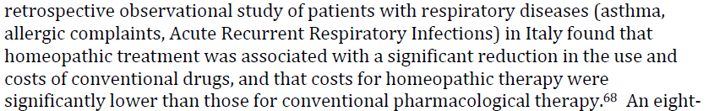
Yet another non-blinded, unrandomized study involving a small number of subjects and doctors with an a priori belief in homeopathy. The groups compared were selected and described in a way that makes it impossible to determine if they were truly comparable, and the measures of outcome were similarly poorly described and selected in a way that could easily generate a misleading impression of both patient outcomes ad costs. More over interpretation of poor-quality research with high risk of uncontrolled bias published in a journal with a demonstrated bias in favor of homeopathy.
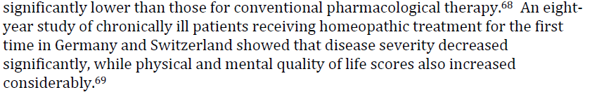
A followup report of the study first reported in Ref. 65, with all of the same methodological problems. Given the lack of proper controls for bias, and the dropout of over half of the original subjects, it is not surprising that those who continued to seek treatment reported they felt better and that they were happy with their care. This is only evidence that people who get better will credit whatever therapy they are receiving, not that homeopathy is actually an effective therapy.
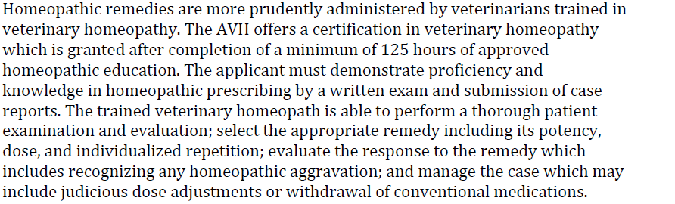
The fact that homeopathy has a complex and extensive set of theoretical principles and specific practices associated with it that can be taught is not evidence that these theories are true or that these practices are effective. Homeopathy is not recognized as a medical specialty in human or veterinary medicine, so claims to special expertise are entirely self-applied. Astrologers, psychics, and practitioners of many other unconventional practices claim expertise and certify themselves as experts in their discipline, yet this does not mean we must accept their claims as true on this basis.
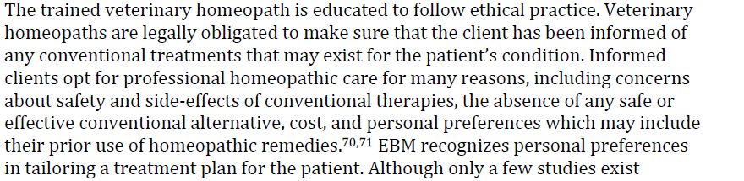
Clients may indeed choose homeopathic therapy, though the evidence does not suggest this is a common choice. A 2007 survey by the National Center for Complementary and Alternative Medicine (Patricia M. Barnes, M.A., and Barbara Bloom, M.P.A Complementary and Alternative Medicine Use Among Adults and Children: United States, 2007. National Health Statistics Reports. Number 12, December 10, 2008.) found 1.8% of Amwricans reported trying homeopathic treatment. Another NIH survey found 3.65% of Americans had tried homeopathy.
In any case, the fact that the public seeks a therapy does not relieve veterinarians of their ethical responsibility to provide full informed consent to clients. Informing clients that homeopathy is not an accepted conventional therapy and that the scientific evidence shows it to be no more than a placebo is the only way to ethically offer this therapy. Confidently claiming, as the AVH does, that it is a safe and effective therapy, and recommending it in place of conventional treatment, is dishonest and unethical.
Clinician expertise has a clearly defined role in evidence-based medicine. It is an appropriate guide for clinical decision making to the extent that it is not in conflict with higher-level and more reliable controlled research evidence. Simply because a clinician believes a therapy to be effective is not sufficient justification for claiming this and offering the therapy if there is substantial scientific evidence indicating the therapy is not effective. This is clearly the case for homeopathy. The unshakable faith of a small group of veterinarians is not an acceptable reason for ignoring the abundant evidence that homeopathy is not an effective therapy.
Homeopathic treatment likely does have an adverse event rate equivalent to placebo treatment since homeopathy is itself a placebo. Adverse events directly related to an inert remedy are, of course, unlikely. As the author points out, mislabeled and improperly produced homeopathic remedies may have direct dangers, but we concede this is uncommon.
The real danger of homeopathic treatment is the rejection or deferral of proper diagnosis and effective scientific medical treatment. The AVH actively discourages the concurrent use of conventional medicine or other CAVM remedies with classical homeopathy, and there is abundant evidence, presented in the CVMA white paper, that believers in homeopathy and homeopathic practitioners do risk injury and death when choosing to eschew conventional care (e.g. Freckelton I. Death by homeopathy: Issues for civil, criminal, and coronial law and for
health service policy. Journal of Law and Medicine. 2012;19(3):454-478.)
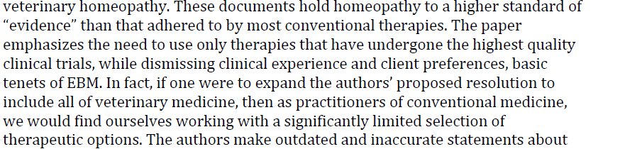
The CVMA resolution is very clear in stating that all veterinary therapies should be held to the same standard and should be validated by sound scientific evidence. It also clearly delineates what constitutes such evidence and how the hierarchy of evidentiary quality and reliability should be construed, in keeping with the accepted principels of evidence-based medicine:
“The AVMA believes that the safety and efficacy of veterinary medical therapies should be established by scientific investigation. In the absence of clear scientific evidence of safety and efficacy, veterinarians must use caution in employing unproven therapies and must be guided by the dictum primum non nocere (first do no harm). When there is sound scientific evidence, and a clear majority of scientists agree, that a given practice is ineffective or poses risks greater than its demonstrated benefits, such ineffective and unsafe philosophies and practices should be discarded.

Scientific validation of medical therapies encompasses a number of levels of evidence, including:

- A plausible theoretical foundation or mechanism consistent with accepted scientific knowledge, including well-established principles of physics, chemistry, physiology, and other scientific disciplines foundational to veterinary medicine.
- Supportive in vitro and animal model experiments demonstrating a biologic effect, dose/response relationship, or other evidence of actions that could potentially provide a therapeutic benefit.
- Clinical trial evidence, in the target species or in others, showing a consistent and clinically meaningful benefit and acceptable risks.

The relative weight of these factors should be determined by the established hierarchy of evidence, with high-level and high-quality evidence outweighing that derived from lower-level and lower-quality research.

It is not necessary for the scientific evidence to be absolutely uniform in order to establish that a practice is ineffective or unsafe. Safeguarding the welfare of veterinary patients and clients requires that veterinarians make reasonable judgments based on the available evidence and proportion the confidence in these judgments to the strength of this evidence. If there is strong scientific evidence that a practice is ineffective or unsafe, the existence of some lower-quality contrary evidence or a minority dissenting opinion does not preclude identifying the given practice as unsafe or without benefit. Like all judgments in science, such conclusions are predicated on the existing evidence and subject to reevaluation or reversal as new evidence is developed.”

There is nothing here that treat homeopathy differently from conventional medicine or that claims no therapy should be employed without perfect clinical trial evidence. However, it is self-serving and disingenuous to suggest that homeopathy should be accepted indefinitely despite the failure, in over 200 years, to develop compelling and high-quality evidence supporting its basic principles or clinical efficacy. Conventional therapies are routinely accepted or rejected far quicker, and for the process of evidence-based medicine to have any utility, we must be willing to make careful, thoughtful, and substantive judgments based on the evidence in a manner and time frame that serves the interests of our patients and clients.
All conclusions in science are, of course, provisional and subject to revision as new evidence is developed. And our confidence in our conclusions should be proportional to the evidence available to support them. So it is possible evidence could be developed to validate homeopathy as a clinical intervention. Currently, this seems about as about as likely as the emergence of evidence that the Earth does not, in fact, revolve around the sun, but in some theoretical sense at least it is possible.

And the evidence concerning homeopathy is not beyond dispute given the generally low level and poor quality of it. However, one great weakness of EBM is that it can be interpreted to mean we cannot draw conclusions about a therapy until near perfect evidence is available. Since this is rarely the case, especially in veterinary medicine, this interpretation renders EBM useless as a decision-making tool.

We must critically evaluate and rank the evidence according to EBM methods, then integrate this with other relevant information, such as biologic plausibility, and make a pragmatic decision based on the evidence that exists. Accepting the provisional nature of such decisions, we must be willing to re-evaluate them as necessary, but it does no good to simply refrain from making them at all if the evidence is less than ideal.

The white paper that supports the resolution makes the case concerning homeopathy in detail, but my own belief that we can legitimately identify it as an ineffective therapy is founded on a few points:

1. Biologic Plausibility: There is no reason to believe homeopathy could work given that it’s theoretical foundations are in conflict with well-established, solidly evidence-based principles of basic science. This is not sufficient in itself to dismiss it since there is, of course, always much we don’t know. But it is a relevant, and I think strong point against the practice. Again, the fact that there is much we don’t know is not a license to ignore what we do know. We don’t entirely understand the mechanisms of gravity, but we refrain from leaping out of windows all the same. Accepting the claims of homeopaths would require a radical revision of our understanding of basic science.

2. Scientific Literature- In 200 years, many studies of homeopathy have been conducted, both pre-clinical studies and clinical trials. A consistent body of positive evidence has failed to emerge. Conventional theories, even radical ones, are routinely validated or dismissed in far less time. The notion of Helicobacter as a cause of GI ulcers went from ridicule to a Nobel prize in a few decades. Given the strong positive claims made for homeopathy, the failure of such positive evidence to appear is difficult to explain in any way other than the theory that homeopathy is merely a placebo therapy.

The white paper does cite numerous systematic reviews of human clinical trials, and these show that most trials are poorly controlled for chance, confounding, and bias, and that when one limits the analysis to the best trials, no treatment effect is seen. Again, it would be optimal to have a larger number of high-quality trials to evaluate, but we must make a decision based on the evidence we have, not the evidence we want. And the most recent review compared homeopathy trials with matched trials evaluating conventional therapies and found a consistently clear treatment effect for the conventional treatments that was not found for homeopathic treatments, suggesting the failure is unlikely to be simply that existing trials were unable to find an effect which does, in fact, exist.

So the question remains, does EBM require us to have a gold-standard RCT or even systematic review level evidence for every indication before we can declare a therapy ineffective? This is not a standard that makes sense or which allows EBM to be of any practical use. In the case of homeopathy, the absence of evidence seems very much to be evidence of absence given the implausible foundations and the failure of numerous attempts to validate the method over two centuries. If even this is not sufficient to declare the therapy ineffective (with, of course, the very small caveat that allows for new evidence to someday emerge), then how can any therapy can ever be discarded or how EBM can provide effective guidance for veterinary clinicians in selecting interventions?

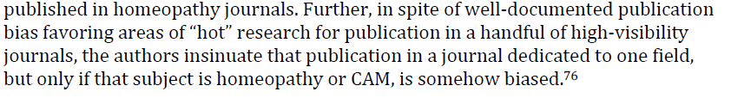
As discussed above, there is ample evidence of publication bias in homeopathy and alternative medicine journals, and in selection bias in this very document. Publication bias is a problem throughout the scientific literature and not at all unique to homeopathy. However, what is unique is that homeopathy, and a few other alternative modalities, have chosen not to generate research that meets the methodological standards of the mainstream literature but to produce a separate-but-equal set of journals in which to publish generally low-quality literature rife with uncontrolled bias. The gradual approximation of truth through scientific investigation requires increasingly higher quality and better controlled studies with more effective controls for chance, bias, and other sources of error and also replication by investigators skeptical of the claims of original authors. This system works well and relatively quickly (though not perfectly or as quickly as we all would like) in conventional medicine. If homeopathy is truly to be judged by the same standards as conventional medicine, it must subject itself willingly, eagerly, and honestly to the same process of evaluation and not sequester its research within a sympathetic community.
Conclusion
A detailed examination of the arguments presented in this white paper, and of the literature cited to support them, only confirms the conclusions of the CVMA white paper. The evidence concerning homeopathy is of poor quality and predominantly negative, especially is preference is given to higher-level and higher-quality research as dictated by the principles of evidence-based medicine. If this is the best that the homeopathic community can muster to validate their strong claims of equivalence or superiority to scientific medicine, then those claims cannot be accepted.

References
This paper is not a report of original research. It is a narrative (not systematic) review of other papers concerning nanoparticles and homeopathy. The authors assert that nanoparticles represent real, biologically active entities with specific effects based on citing Ref. 4 and 9 and other similar research reports, none of which actually support this assertion. They then add a great deal of completely unsupported speculations built on this shaky foundation.
[published in alternative medicine journal]
http://www.sciencebasedmedicine.org/index.php/homeopathy-as-nanoparticles/
This study contained no controls and did not verify the contents of the purported homeopathic preparations examined. Without such controls for bias and contamination, the results are meaningless.
[published in homeopathy journal]
http://www.sciencebasedmedicine.org/index.php/homeopathy-and-nanoparticles/
The paper begins with a clear statement that homeopathy is known to be effective, and there is no mention of blinding or any other control for bias, so the influence of bias on the results must be considered, especially as the study was published in a dedicated homeopathy journal.
Nanoparticles were found in all substances, including controls. Test substances shaken in glass vials had more silica than substances in glass vials which were not shaken. This proves that water has nanoparticles in it and that more such particles can be gotten from glass containers if the containers are agitated. It does not prove that homeopathic remedies contain healing powers attributable to these particles even when no pharmacologically active substances remain. If that were true, then the control solutions would also be remedies and every liquid on the planet would be medicine (or poison).
[published in homeopathy journal]
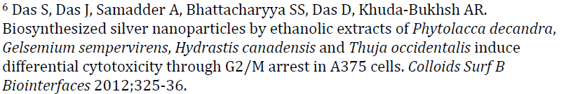
This study involved mixing alcohol extracts of plants (NOT homeopathic preparations made by serial dilution and succussion) with silver nitrate solution and then identifying nanoparticles in the mixture as well as investigating whether these particles had any apparent effects on DNA or cells in vitro. For most aspects of the experiment, there were no control solutions tested, and of course there could be no blinding of investigators without controls. Particles were found and inconsistent effects on DNA and cell growth appeared to occur. This does not have any obvious relevance to homeopathy, and it certainly is not a validation of the claim that nanoparticles, of silver or anything else, are responsible for claimed clinical effects of homeopathy.
It is worthwhile noting that if silver nanoparticles did have anything to do with homeopathic remedies, there have been reports concerning toxic effect of such particles, so once again one would have to establish safety as well as efficacy even if this theoretical notion were true. (Johnston HJ, Hutchison G, Christensen FM, Peters S, Hankin S, Stone V (April 2010). "A review of the in vivo and in vitro toxicity of silver and gold particulates: particle attributes and biological mechanisms responsible for the observed toxicity". Crit. Rev. Toxicol. 40 (4): 328–46.; Ahamed M, Alsalhi MS, Siddiqui MK (December 2010). "Silver nanoparticle applications and human health". Clin. Chim. Acta 411 (23–24): 1841–8.)
The core concept in this paper is that once diluted to a certain point, at which only nanoparticles of a substance remain, further dilutions aren’t actually dilutions because the nanoparticles float on the surface and aren’t suspended in the solution, so subsequent preparations have the same (ng/mL) concentrations of these particles. They then made a solution of gold nanoparticles via a chemical reaction (NOT a homeopathic solution as it would be prepared for medical use), and attempted to measure the concentration of gold nanoparticles after subsequent dilutions, with or without various kinds of shaking and the addition of milk sugar.
The results seem to suggest that beyond relatively low dilutions by homeopathic standards (about 6-7c), further dilutions don’t reduce the concentrations of nanoparticles in the solution. There are a number of reasons why this finding may be simply an error, including the obvious possibility that the final level of nanoparticles in solution beyond which they cannot be diluted is the level of nanoparticles contaminating the diluent and has nothing to do with the starting material.
However, if the results are not an error, then they contradict the fundamental principle of homeopathy, that dilution and succession makes remedies stronger and that more diluted remedies have meaningfully different clinical effects from less diluted remedies. If nothing above 6c is any different no matter how many times it is diluted and shaken, then most homeopathic remedies (which are above 12c-30c, and sometimes much higher) are diluted and shaken many times for no reason.
And, of course there remains the complete failure of research to show that these particles have specific, predictable, and beneficial effects on living organisms and how these effects are somehow retained in homeopathic solutions but not in ordinary drinking water, alcoholic beverages, and other substances with far higher levels of the materials homeopaths claim to use as the basis for their remedies.
This paper involves the viral load (copies/mL) in people affected with and treated for hepatitis B. This has no relevance to homeopathy and does not support the claims that unmeasurable or infinitesimal amounts of material in low-dilution remedies, much less the complete absence of material in ultradilute remedies, have meaningful biological effects..
This study does not relate directly to homeopathy or involve homeopathic remedies. It purports to show some electromagnetic emission by DNA particles after certain bacteria are disrupted by filtering and shaking and resulting naked DNA diluted. This effect was not detected in low dilutions and was inconsistent in high dilutions, with no apparent relationship between the amount of DNA present and the size of the effect. It disappeared entirely at the highest dilutions. This contradicts the claims that the potency of homeopathic remedies is inversely proportional to their level of dilution.
The effect also only lasted 24-48 hours, so unless homeopathic remedies are employed within 48 hours of their manufacture, it is unclear how this phenomenon could explain the purported effects of these remedies.
The provenance of the study is suspicious. It was not published in an established, respected journal. It appeared in the first volume, second issue of a new journal, Interdisciplinary Sciences–Computational Life Sciences. The article is not written in the usual scientific format – it lacks separate sections for Methods, Results, etc. There are numerous typos and language errors that should have been caught by any proofreader even if the peer reviewers missed them. The editor in chief is in Shanghai, and four of the other editors are in various Chinese cities, while the other two are US based but have Chinese names. Montagnier is on the editorial board. It says it is peer-reviewed, but the speed of the process is worrisome: the Montagnier article was received 3 January 2009, revised 5 January 2009 and accepted 6 January 2009.
http://www.sciencebasedmedicine.org/index.php/the-montagnier-homeopathy-study/
This paper mostly reports research studies that examine the effect of stressing cells in vitro with heat and then subjecting them to milder increases in temperature and measuring the production of heat shock proteins and survival of cells given different treatments. Some studies also exposed cells to low but measurable quantities of known toxins.
This is an attempt to demonstrate that low doses of a stressor given after high doses can improve recovery from stress. It has very little relevance to the clinical practices of homeopathy. Ultradiluted remedies and remedies prepared by dilution and succession according to homeopathic guidelines were not used. Only heat (which cannot be made into a classical homeopathic remedy) and known toxins were used, not any of the thousands of other remedies in clinical homeopathic use. In any case, these studies did not report any blinding or consistent control procedures, and they did not involve actual homeopathic remedies, so they cannot be said to validate that such remedies have meaningful biologic effects.
[published in homeopathy journal]
The abstract of this article (A) seems to suggest that it is essentially the same paper with the same authors as Ref. 11 above (B). Therefore, it adds no additional evidence and suffers from the same limitations.
(A)Postexposure conditioning, as a part of hormesis, involves the application of a low dose of stress following exposure to a severe stress condition. The beneficial effect of a low level of stress in postconditioning hormesis is illustrated by a number of examples found in experimental and clinical research. Depending on whether the low-dose stress is of the same type of stress or is different from the initial high-dose stress causing the diseased state, postconditioning is classified as homologous or heterologous, respectively. In clinical homeopathy, where substances are applied according to the Similia principle, the same distinction is found between the isopathic and the 'heteropathic' or homeopathic use of low dose substances. The Similia principle implies that substances causing symptoms in healthy biological systems can be used to treat similar symptoms in diseased biological systems. Only when heterologous substances are tested for therapeutic effects, the Similia principle can be studied. It is then possible to compare the effect of treatment with the degree of similarity between the diseased state and the effects caused by different substances. The latter research was mainly performed with cells in culture using heat shocked cells post exposed to a variety of stress conditions in low dose.
(B) This paper describes the results of a research program focused on the beneficial effect of low dose stress conditions that were applied according to the similia principle to cells previously disturbed by more severe stress conditions. In first instance, we discuss criteria for research on the similia principle at the cellular level. Then, the homologous (‘isopathic’) approach is reviewed, in which the initial (high dose) stress used to disturb cellular physiology and the subsequent (low dose) stress are identical.

Beneficial effects of low dose stress are described in terms of increased cellular survival capacity and at the molecular level as an increase in the synthesis of heat shock proteins (hsps). Both phenomena reflect a stimulation of the endogenous cellular self-recovery capacity. Low dose stress conditions applied in a homologous approach stimulate the synthesis of hsps and enhance survival in comparison with stressed cells that were incubated in the absence of low dose stress conditions. Thirdly, the specificity of the
low dose stress condition is described where the initial (high dose) stress is different in nature from the subsequently applied (low dose) stress; the heterologous or ‘heteropathic approach.

The results support the similia principle at the cellular level and add to understanding of how low dose stress conditions influence the regulatory processes underlying selfrecovery. In addition, the phenomenon of ‘symptom aggravation’ which is also observed at the cellular level, is discussed in the context of self-recovery. Finally, the difference in efficiency between the homologous and the heterologous approach is discussed; a perspective is indicated for further research; and the relationship between studies on
the similia principle and the recently introduced concept of ‘postconditioning hormesis’ is emphasized.

For a paper published in an alternative medicine journal, reviewing papers published primarily in alternative medicine journals, all with the clear intent of proving the a priori position that homeopathy is valid, even these authors were forced to admit that, “No positive result was stable enough to be reproduced by all investigators.” In other words, though there were many positive studies found, they were not of high enough quality to be consistently replicated in order to draw solid conclusions from the data.
This is consistent with the findings of another review of the in vitro research, cited in the CVMA white paper, which found “There is a lack of independent replication of any pre-clinical research in homeopathy. In the few instances where a research team has set out to replicate
the work of another, either the results were negative or the methodology was
questionable.”(Vickers AJ. Independent replication of pre-clinical research in homeopathy: a systematic review. Forschende Komplementarmedezin. 1999;6:311-20.)

Actually, only 46 of the publications reviewed were journal articles, and about half (25) of these were in homeopathy or alternative medicine journals. Only 18% of the studies reported randomization and only 33% reported blinding, illustrating the poor control for bias in many of these studies. Only 31% of studies reported sucussed controls. Only 18 of the 67 experiments met the quite generous minimum score for quality control, and of these only 18% reported successful replication.
This paper confirms the statements in the CVMA white paper that the higher the quality the less likely a positive result will be reported. The authors even acknowledge that, “Publication
Bias…is very likely in the field of homeopathy [and] would cause a tendency to positive results. For example, unsuccessful pilot studies in search for a viable test system may not have been published.”
These are pretty lackluster results, especially given that the paper was published in an alternative medicine journal (which even the authors acknowledge increases the influence of publication bias) and was funded by a foundation specifically set up to support alternative medicine research. If this is the best that can be found, even with clear bias, to suggest there is meaningful in vitro research supporting the claims made for homeopathy, then the case is weak indeed.
[published in alternative medicine journal]

This was not a systematic review but a review in which the authors identified and selected studies to include without explicit, replicable methods fixed in advance. This increases the influence of selection bias in a review. And many sources of study reports other than peer-reviewed journals were accepted. No effort was made to identify or control for publication or selection bias. And once again, this review was published in a dedicated homeopathy journal and funded by a foundation dedicated to the promotion of alternative medicine. The lack of control for bias is a serious limitation for this review.
Wide latitude was given to what was considered a “replication,” so similar experiments not actually involving the same remedies or ingredients were often counted as replications. And studies were included without any meaningful statistical analysis if they were published before 1940. The authors acknowledge the low quality standards for included studies; “One will agree that these standards are not too high, i.e. that we are not referring to “Gold Standard” publications only.”
Despite the obvious intent and effort on the part of the authors to dig up evidence supportive of homeopathy, they were forced to admit, “However, when comparing the studies in detail one must conclude that no independent repetition trial yielded exactly the same results as the initial study, and methods always differed to a smaller or larger extent.”
And after all these opportunities to select and evaluate studies in a way that supported their pre-existing beliefs, the authors reported that, “When all repetitive (but not initial) studies are considered, 69% report an effect comparable to that of the initial study, 10% a different effect, and 21% no effect.” However, “when only the independent replication studies are taken into account,” the numbers drop to “44% comparable, 17% different, and 39% no effect.”) These “independent” replications are still , of course, carried out by believers in homeopathy and, in many cases, published in dedicated alternative medicine journals, but they show far lower rates of “success” at replicating initial results. This is not suggestive of a clear underlying phenomenon consistently identified in multiple studies but of the influence of bias and poor methodology on the outcome of research studies. Again, if this is the best that can be said of in vitro homeopathy research, it is far less compelling that the results expected, and obtained, for conventional medical therapies.
[published in homeopathy journal]
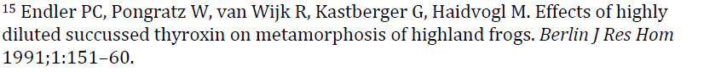
The measurements made of metamorphosis stage were entirely subjective, with arbitrary cutoffs applied to identify instantaneous transitions in the continuous process of metamorposis. A 2-legged tadpole with “weakly developed” hind legs was coded this way one day and as a 4-legged tadpole the next day. The tail was scored as “reduced” at some arbitrary point. And while the authros were reportedly blinded to the test solutions, such subjective measurements are at high risk of unconcious bias.
The results of individual experiments, and experiments conducted at different locations, were inconsistent, with differences reaching statistical significance at some time points or for some trials but not at others and with no pattern to the particular time points or locations at which significant differences were reported. Of 10 individual experiments reported, significant differences were seen in only 5. This is more compatible with Type I error than with a consistent, predictable treatment effect.
And at no time were the results of individual experiments of any biological significance. The overwhelming majority of tadpoles were scored as reaching the same arbitray stage on the same day, with differences in the proportion in the test and control groups typically only a few percent.
To try and overcome this lack of consistent results, data were pooled. This pooled data often reached statistical significance when the individual test data did not, but it is well-known that such pooling increases the rate of false positive findings (Ioannidis JPA (2005) Why Most Published Research Findings Are False. PLoS Med 2(8): e124. doi:10.1371/journal.pmed.0020124).
A recently published attempt at replicating these results does claim to find a similar pattern, however the authors report, “the differences in the frequency of larvae reaching the 4-legged stage and the stage with reduced tail were not statistically significant (p > 0.05).” Once again, this desired statistical significance is achieved by pooling data. (Harrer, B. Replication of an experiment on extremely diluted thyroxine and highland amphibians. Homeopathy. Published online Dec. 20, 2012 doi:10.1016/j.homp.2012.09.003)
[published in homeopathy journal]

A study nearly identical to Ref. 15 performed by the same research group, except with a different, yet still subjective measure. Counts were made of frogs who attempted to climb out of their containers and compared between treatments. Again, an unpredictable collection of significant and insignificant differences was observed, consistent with type I error.

[published in homeopathy journal]

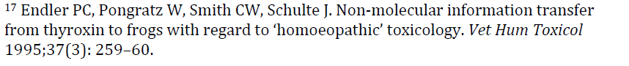
Yet another experiment very similar to Refs. 15-16 performed by the same research group and with the same inconsistent results. In this study, not only were effects reported for homeopathic dilutions of thyroxine placed into the water with the animals, but the same or even stronger effects were reported when an audio recording of the homeopathic remedy was played to the animals or when the remedy was placed in their environment in a sealed container. The authors claim that this suggests no actual physical contact between the remedy and the subject is needed to obtain an effect, which not only contradicts established understanding of physiology and physics but contradicts the hypothesized role of nanoparticles proposed in this document as an explanation for the purported effects of ultradilute homeopathic remedies.

As previously discussed in the CVMA white paper, this study has long been discredited. Because the findings were so revolutionary, the journal in which it was published took the unprecedented step of arranging for an independent team of investigators to observe replications of the experiment. This team found that the results had been generated by an unblinded technician, and when this individual was unaware of the treatment given to each sample, the positive findings disappeared.(Maddox, J. Randi, J. Stewart, W. "High-dilution" experiments a delusion. Nature1988;334:287-290.)

Subsequently, multiple attempts by independent researchers to replicate the original experiment also failed to find an effect.( Ovelgonne, J.H.; Bol, A.W.; Hop, W.C.; Van Wijk, R. Mechanical agitation of very dilute antiserum against IgE has no effect on basophil straining properties. Experientia 1992;48(5):504–8. and Hirst, S.J.; Hayes, N.A.; Burridge, J.; Pearce, F.L.; Foreman, J.C. Human basophil degranulation is not triggered by very dilute antiserum against human IgE. Nature 1993;366(6455):527.)

A review published in a homeopathy journal in 2009 concluded that after twenty years of research, it was still impossible to determine conclusively that purported effects of ultradilute solutions on human basophils were not due solely to artifact.(Ennis, M. Basophil models of homeopathy: a sceptical view. Homeopathy 2010;99(1):51–56.)

As already discussed, the balance of the evidence that homeopathic solutions can influence basophil degranulation is negative since effects reported are inconsistent and not replicable. Though this study purports to have found positive results, it is only one element in a body of evidence which does not support that conclusion. Even the authors of this study acknowledge, “the literature in this field is not always consistent, with some experiments showing that highly diluted histamine activates rather than inhibiting the same cells, while another group failed to replicate the reported inhibitory effects of high histamine dilutions…the research in this field has until now failed to account for the discrepancies observed between different laboratories…there has been no positive result stable enough to be reproduced by all investigators.” In no area of conventional medicine, would such inconsistent and unreproducible results be considered adequate evidence of a real, predictable, and useful treatment effect. Trying to ignore the context and claim studies such as this as validations of homeopathy is dishonest.

As already discussed, the balance of the evidence that homeopathic solutions can influence basophil degranulation is negative since effects reported are inconsistent and not replicable. Though this study purports to have found positive results, it is only one element in a body of evidence which does not support that conclusion.

In this study, as in the other, results were variable and not consistently significant. One laboratory had such markedly different results from the others that the authors felt obliged to explain this. They elected not to identify it as a potential error but stated, “We believe that this is due to the varying sensitivity of basophils depending from the donors.” The variability of results and lack of any dose-response relationship prompted the authors to further state, “We are not yet able to propose any theoretical explanation of these findings…We are…unable to explain our findings and are reporting them to encourage others to investigate this phenomenon.”

[funded by a homeopathic research institute]

Low dilutions were used so some pharmacologically active ingredient might have existed in the preparation. Test and control solutions were given by IP injection, contrary to the established principle that homeopathic remedies should be given orally. In the first set of experiments, with the low-dilution preparation, there was no significant difference between the test solution and the placebo control, while the active control (diazepam) group showed significantly different behavior. However, in the second set of experiments, also using the low dilution test material, there was no difference between the placebo and the active control, but there was a difference between these and the test group. A replication of this second experiment in a different strain of mouse yielded variable and non-significant results. The most plausible explanation for these inconsistent results is simply a lack of a consistent treatment effect and random variation in behavior.

Replication of these two sets of experiments using the low dilution and two high-dilution preparations and a placebo (with no active control), yielded similarly inconsistent results. The first set found no significant differences between treatment groups. The second set found some significant differences but this time there was no effect of the low dilution (unlike the first series of trials, but there were significant differences in the groups receiving the higher dilutions. Again, the most plausible explanation for the smattering of statistically significant differences without any consistent pattern among trials is random error, not a predictable, consistent, and biologically meaningful treatment effect.

[published in alternative medicine journal and funded by a company making homeopathic products]
A very recent study with apparently dramatic results. Given the history of such studies in homeopathy turning out to be due to error or to be unrepeatable, even when published in mainstream journals (see Ref. 18 above), these results will need to be independently verified under proper controls before they can be said to overturn the tremendous weight of negative evidence showing homeopathic to be inert and ineffective.
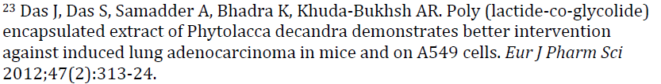
This study investigates a plant extract, not a homeopathic preparation or method.

This study is of such poor methodological quality it is surprising that it passed peer review. For one thing, though there are many differences claimed to be seen between treatment groups, there are no statistics to show that the differences described are significant. The authors simply relied on their own subjective impressions of the results to conclude that the remedies they tested had meaningful effects.

Another problem is that the diluent used for the homeopathic remedies was not water; it was 87% “extra neutral alcohol,” and this alcohol was used as the control….When one examines the results of in vitro survival of cancer cells, the solvent alone is killing up to 50% of them! Not only that, but the normal control cells appear to be more resistant to the effect of the solvent, with very little effect seen. In fact, by the lack of a clear dose-response curve for the solvent-only control, with the measurement fluctuating around a point slightly lower than that seen with no solvent added, you can get an idea of the variability of this assay from well to well, which is quite a bit….All this shows is that adding 10 μl/ml of 87% alcohol has a significant effect on cell viability for the cancer cell lines. They have not shown in any way that I can tell that any of their remedies have a significant effect on cell viability compared to the alcohol solvent alone…

It is possible that perhaps a 3C homeopathic dilution might have an effect on cells. There could be an actual drug remaining there. However, 30C and 200C homeopathic dilutions leave nothing behind, and there is nothing in this paper to show that there is an effect above and beyond solvent effects from either of these remedies. And examined closely, there’s nothing in this paper to show that the 3C homeopathic dilution really has any effect above and beyond solvent toxicity effects.

Even one of the authors, Dr. Alison Pawlus, thought it was not a sound study*, and asked to have her name removed from the paper.

* “As an unintentioned co-author on this study, I feel obligated to respond, particularly since I asked to not be included because I did not think it was a sound study that would add to confusion.
The reason was that I was not convinced it was a sound study. I chemically analyzed the homeopathic medicines, using direct infusion MS, a technique 10 folds more sensitive then the published HPLC. My work was not included.
Outside of me not finding the argument for homeopathic scientifically plausible, I had one major concern with this study scientifically, if assuming I was completely wrong in not believing in homeopathy (keeping the most open mind possible, because I do not believe that water has memory, or if it does then I’m getting homeopathic doses of everything just by breathing in and drinking tap water, nor do I believe that likes-treating-likes makes any rational sense etc. etc.).
That concern was the alcohol content. It is common knowledge with cell based assays that even small amounts of ethanol (talking about smaller than 5%) dosed directly onto cells in culture has profound cytotoxic effects. So, since these medicines contained ethanol, I felt that unless they contained the same EXACT amount of ethanol (which they did not), the study was irrelevant. Some medicines were created with different percentages of ethanol and considering they were put in plastic tubes (a source of phthalate esters, a cytotoxic compound found in plastics), not made on the same day, and sent across an ocean, then small differences were inevitable.
The negative control was made after I requested a negative control to be made in the same manner, but all of the samples should have been made in the same manner, at the same time, with same amount of shaking between multiple dilutions. This is important because ethanol is a good solvent for phthalates and is volatile. Since large percentages of ethanol was used, a change of a couple of percentages could easily occurred during the many stages of preparation and during the cell studies.
Therefore, I believe this study demonstrated changes in alcohol percentages on cells rather than the efficacy of homeopathic medicine.”
http://scienceblogs.com/insolence/2010/03/04/a-homeopathic-bit-of-breast-cancer-scien/

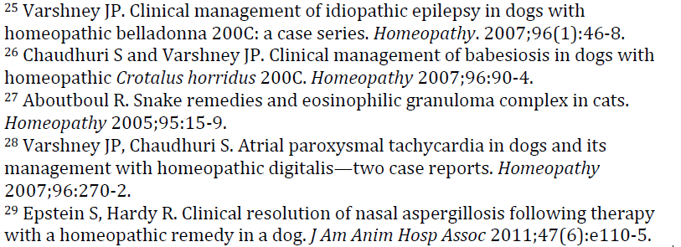
Case reports and case series make up the bulk of the evidence for homeopathy because they are uncontrolled anecdotes in which an ineffective therapy can easily appear effective due to spontaneous remission, regression to the mean, placebo effects, bias, and other sources of error. Such anecdotes exist to support the effectiveness of blood-letting, faith healing, and every other medical intervention ever invented. Either everything one of these therapies is effective, or anecdotes are not sufficient to validate a medical therapy. While case reports are appropriate to suggest hypotheses that merit further investigation, they cannot be used to prove or disprove such hypotheses. This is why controlled, formal research is necessary.
Given the 200 years since the invention of homeopathy, and the failure of controlled research to demonstrate the biologic plausibility or clinical effectiveness of the approach, case reports are insufficient to demonstrate the safety or efficacy of homeopathy. In this context, this is a meaningless type of evidence which serves only to illustrate how weak the evidence base for the practice really is.
This is one of a series of studies by the same author. Each contained significant methodological weaknesses, especially in the statistical methods which the author herself acknowledged in a subsequent meta-analysis. In response to these, the author conducted a larger trial in 2006, which found no effective of the homeopathic remedy vs placebo. The flaws of these trials have been discussed extensively (e.g. Sampson, W., and London, W., 1995 Analysis of Homeopathic Treatment of Childhood Diarrhea Pediatrics Vol. 96 no. 5 pp. 961-964 (a response to Jacobs 1994).
In this first trial, the statistical analysis chosen by the authors was inappropriate for the types of data which were obtained - the fact that chosen end points were vague and a variety of different remedies were used were among the factors which rendered the chosen analysis inadequate. Although it was claimed that participants were randomised into 2 groups there were considerable and statistically significant differences between the 2 groups, with the homeopathic group being both older and heavier, which would have meant it was likely that members of this group would show a quicker recovery from diarrhea anyway, regardless of the type of treatment.
By way of explanation the authors claimed, not unreasonably, that this (statistically significant) discrepancy was as a result of chance variation (and they later applied a statistical trick to work around the problem). In contrast, at the end of the trials, when the alleged benefits of homeopathy were announced in the conclusion, this claim was justified, even though the actual differences between groups were slight, on the basis that the results of the trial also were statistically significant. No mention that the results themselves were just as likely to have been as a result of chance as the initial disparity between groups.
Another difference between the groups in one of Jacob's trials was that there was significantly fewer bacterial isolates from the stools of the participants in the homeopathic group than there were in the placebo group - one reviewer has speculated this could have been as a result of treatment with antibiotics which apparently is common practice in some areas and which the researchers may or may not have been aware of.
The trials conducted by Jacobs et al dealt only with mild cases which are often self-limiting anyway. It is noteworthy that the authors use the correct clinical term for such cases by describing them as “acute” - the strict, technical meaning of this term is “rapid onset and short lasting”, not, as lay readers may assume “severe”. The term “acute” in the medical context has no bearing on whether a condition is severe or mild. Thus the trials had questionable clinical and public health significance despite grandiose claims to the contrary.
Dr Jacobs herself acknowledges the lack of statistical power in her first three trials when embarking on the metanalysis (Jacobs, J., Jonas, W.B., Jimenez-Perez, M., Crothers, D., (2003) Homeopathy for childhood diarrhea: combined results and meta-analysis from three randomized, controlled clinical trials Pediatric Infectious Disease Journal Vol. 22 no. pp. 229-34). There are also a number of discrepancies carried over from the three trials in the metanalysis which appear magnified when the figures are combined. Again, an inappropriate statistical analysis is used, there are imbalances between the homeopathic and the placebo groups and the end point for which such great significance is claimed is a minute difference between homeopathic and placebo groups such as could be accounted for by pure statistical noise - variations in times of sampling for example. The difficulty of making accurate measurements in diarrhoea trials is highlighted in a paper by Johnson et al (Johnston, B.C., Shamseer, L., da Costa, B.R., Tsuyuki, R.T., Vohra, S., 2010 Measurement issues in trials of pediatric acute diarrheal diseases: a systematic review Pediatrics Vol. 126 no.1 e. 222-231).
As Wallace Simpson of Science based Medicine says, “what actually occurred, even at maximum difference between homeopathy and controls, was a difference between having 3 (or slightly more) stools per day and no more than 2 stools per day for 1 day or so at only one of four measured periods of the study. The calculated difference in terms of days to the end point was slightly more than a half a day. Most patients and most family members would hardly be aware of such a small difference.”
At the end of the series of original papers Dr Jacobs acknowledged the low statistical power of the three studies which went to make up the metanalysis (2003) and called for other, larger trials to be carried out in the future. As mentioned above, she later carried just out such a trial herself there was no difference between placebo and verum groups! (Jacobs, J., Guthrie, B.L., Montes, G.A., et al. 2006 Homeopathic combination remedy in the treatment of acute childhood diarrhea in Honduras Journal of Alternative and Complementary Medicine Vol. 12 pp. 723-732
“There was no significant difference in the likelihood of resolution of diarrheal symptoms between the treatment and placebo groups... The homeopathic combination... did not significantly reduce the duration or severity of acute diarrhea in Honduran children...”)
http://www.rationalvetmed.org/papers_i-j.html#Jacobs1994
The authors conclusions acknowledge that this study, even if it were methodologically unassailable, would only be suggestive and would require better quality evidence to confirm its findings: “This study suggests that homeopathy may have a role in treating persistent MTBI. Our findings require large-scale, independent replication.” Thirteen years after this paper, such evidence still does not exist.
The methods, however, did have some significant limitations which make the conclusions even less reliable. As others have pointed out, “Their outcome measure is the results of a questionnaire, which they administered to both groups, before and after the treatment. The authors admit that this tool had not been validated in previous trials, which in itself is a major problem - they simply have no idea if the primary outcome measure of the trial measures what they think it does.
The questionnaire comprises 3 sections with a total of 65 questions about various activities, to which the subjects reply by scoring a 1 -5; (1 = never, 2 = rarely, 3 = sometimes etc...). These are rank ordered ordinal variables which means that while they progress in order, they don't provide quantitative information. So for example, someone who has a weight of 60kg is always exactly twice as heavy as someone whose weight is 30kg. However someone who replies "most of the time' (a score of 4) to the question "How often do you feel frustrated" is not always frustrated exactly twice as much as someone who had responded "rarely" (a score of 2). Ordinal variables like these have to be analysed statistically in a different manner to ratio scales like weight, but the authors do not do this.
Instead they add up all the numbers they get in each part of their questionnaire before and after the treatment and present it an arithmetic mean. They then perform a t test for each of seven sections of the questionnaire. Doing this they found no real differences in the majority of the data ("Our data revealed the limitations of our standardized tests to detect changes from treatment") Out of the seven analyses they performed one is significant (p=0.009) the rest are not. They then perform a whole raft of multivariate analyses, with again one or two results they claim are significant.” (http://www.rationalvetmed.org/papers_c.html#Chapman1999)
This review evaluated one systematic review of homeopathy for treatment of fibromyalgia. That review, in turn, evaluated 4 randomized clinical trials and concluded that despite reported positive results, the evidence did not support the conclusion that homeopathy was an effective therapy for this disorder.
Perry R, Terry R, Ernst E. A systematic review of homoeopathy for the treatment of fibromyalgia. Clin Rheumatol. 2010 May;29(5):457-64. Epub 2010 Jan 23.
“Four RCTs were found, including two feasibility studies. Three studies were placebo-controlled. None of the trials was without serious flaws. Invariably, their results suggested that homoeopathy was better than the control interventions in alleviating the symptoms of FM. Independent replications are missing. Even though all RCTs suggested results that favour homoeopathy, important caveats exist. Therefore, the effectiveness of homoeopathy as a symptomatic treatment for FM remains unproven.”[emphasis added]
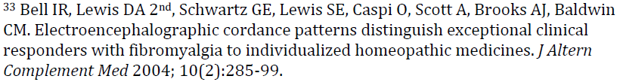
This is a truly bizarre experiment. Subjects were individuals diagnosed with fibromyalgia, which is a challenging disorder to diagnose as there are no objective diagnostic tests or universally accepted criteria to establish the diagnosis. Individuals were then randomly assigned to homeopathic treatment (individualized, not standardized, so different patients received different treatments) or placebo. Of the 53 patients who completed the study, 6 were identified as having improved more than all the others based on two subjective assessments.
All subjects were subjected to an electroencephalographic (EEG) measurement and the calculation of a value called cordance. This is a measurement developed to evaluate activity in different brain areas and possibly predict response to drug treatment for psychiatric disorders, though this potential use is still being evaluated and is not commonly employed. Subjects in this study had baseline EEG measurements and then had measurements taken while sniffing the homeopathic remedy or placebo. The EEG pattern of the 6 “exceptional responders” (those believed to have improved the most) was evaluated, and the authors concluded it was different from that of other subjects. They then extrapolated from this conclusion to suggest that cordance might be a useful way of predicting which homeopathic remedies would be appropriate for which patients.
The subjectivity of diagnosis and evaluation of response to treatment, the a priori assumption that apparent improvement was due to homeopathic treatment, the lack of standardization of treatment, the use of an uncommon and not widely accepted imaging technique, the evaluation of the effects of merely sniffing homeopathic remedies and placebo solutions rather than taking them orally, as is done in actual treatment, and many other limitations render the conclusions of this report unreliable. It was not even designed to validate homeopathic treatment per se but to evaluate a method for predicting response to such treatment, which was assumed to be efficacious from the beginning. It certainly does not provide evidence for the efficacy of homeopathy.

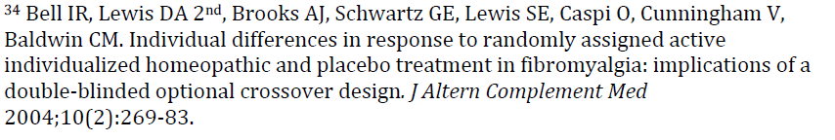
Once again, this study involved a subjectively diagnosed disorder and entirely subjective outcome measures. Patients were randomly assigned to individualized homeopathic treatment or placebo. The authors looked at how many of the subjects elected to change from one treatment group to another after 4 months of treatment and found no differences between treatment and control groups, suggesting patients receiving homeopathic treatment were not experiencing greater improvement that those in the placebo group. Rather than acknowledging that this shows no effect of treatment, the authors chose to interpret the data to suggest some people respond better than others to homeopathic therapy, an obviously biased manipulation of the data to reach a conclusion already determined in advance.
[published in alternative medicine journal]
This study suffers from similar flaws to Ref. 33, including unconventional and subjective diagnostic and evaluation measures. Although the placebo was claimed to be indistinguishable from the remedy no check was done of participants at the end of the trial to determine if they knew what group they were in. Somewhat unorthodox outcome variables were chosen - tender point pain on palpation for instance rather than conventional pain score assessments such as McGill Affective Pain scores or McGill Sensory Pain ratings both of which showed no difference between groups at 3 months. There are no objective tests available for fibromyalgia, accordingly all outcome measures are indirect. Other problems include low patient numbers, flaws in the randomisation process, statistical differences in end-points only seen after statistical 'adjustment' of the results (in table 2).
http://www.rationalvetmed.org/papers_b.html#Bell2004
This is not a report of original research, but a narrative (not systematic) review of studies of homeopathy for a hodgepodge of conditions all of which have something to do with the immune system. The clearly subjective criteria for locating and including studies, and the arbitrary way of selecting and categorizing indications, introduces significant risk of bias. The review also includes many uncontrolled studies as well as case series and other forms of low quality evidence, which are not graded or weighted according to the accepted hierarchy of evidence, and reports from sources other than peer-reviewed scientific journals.

The author frequently argues that the accepted practices of evidence-based medicine may not apply to homeopathy, indicating a commitment to a deliberately “separate-but-equal” approach to evaluating homeopathy versus conventional therapies. This practice of moving the goalposts to protect a favored practice from the same standard of proof applied to conventional medicine is common in evaluations of homeopathy.
The author, for example, rejects the notion that demonstrating homeopathy is more effective than placebo is necessary for establishing that homeopathy is effective:
“On evaluating the evidence in favour of and against the clinical effectiveness of homeopathy, it should be pointed out that the placebo question is important, but not equivalent to the question of whether the homeopathic approach is clinically effective. In classical, individualised homeopathy, the evaluation parameters are based upon specific rules that involve
considering the totality of a patient’s symptoms…Patients with the same disease receive different prescriptions, and often the prescription changes during the course of the treatment…This methodological aspect, related to the context of the treatment (e.g.: patient-physician interactions), seriously calls into question the use of double blinding for testing homeopathy…”

He also doubts the value of the established hierarchy of evidence, which considers properly conducted randomized clinical trials as superior to lower-level evidence, such as case reports.
The author acknowledges both the methodology weakness of most of the studies considered and the non-standard methods of evaluating their quality that he employs, and the fact that these limitations prevent drawing the conclusion that homeopathy is effective from the research evaluated in this review:

“Clearly, the few dozen papers reported in this review are so highly heterogeneous, in terms of the investigated disease conditions, the tested drugs, and their experimental designs, that any meta-analysis is precluded (with a few exceptions that have been mentioned). It is only possible to make a semiquantitative evaluation… dividing treatments into categories and fitting interventions into these categories is never easy since categorisation always involves a degree of subjective judgement and is sometimes controversial. This is even more arbitrary when complex interventions as those of homeopathic care are compared. However, grouping treatments in a scale of different clinical evidence may be useful when taken as a tentative summary, instead as a definite conclusion or as a recommendation for use…”

Nevertheless, the author goes on to apply an idiosyncratic method of categorizing the admittedly low-quality evidence and then concludes it is strong enough to justify claims of a benefit for homeopathy. He then suggests that the fact that the evidence is more likely to be negative in controlled clinical trials, which attempt to limit bias and error, than in uncontrolled observations, that this should be seen as evidence not that homeopathy is ineffective but that the accepted system for evaluating medical therapies is inadequate to evaluate homeopathy.

Clearly, this review is rife with uncontrolled bias and is an attempt to put the most favorable possible spin on evidence which, when held to the standards of science-based medicine, does not validate the methods the author favors.

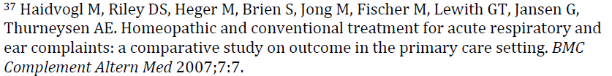
This study compared the rates of “major improvement” or “complete recovery” in people with acute upper respiratory symptoms. The vast majority of patients in both groups (86-87%) reported one of these two subjective outcomes within 14 days. There was no difference in the recovery rates of patients treated with conventional or homeopathic treatment. There are a number of methodological problems with the study. Patients were not randomized and so selected the providers (conventional, alternative, or mixed) and thus the treatments they received. This also means, of course, that neither patients nor doctors could be blinded to what treatment was used. And while followup information was collected via telephone by individuals supposed to be blind to the treatment groups, it would not take more than a casual mention of treatment or doctor on the part of a patient to unblind the interviewers, and no assessment of this possibility was done. Apart from their selection of healthcare providers, there were a number of other differences between the groups at baseline that might have influenced any comparisons between them.
A variety of homeopathic remedies were used. Most of the conventional therapies were antibiotics (which would not be effective for many of the common causes of upper respiratory symptoms), as well as nasal sprays and analgesics. The most likely explanation for the results is simply that most upper respiratory symptoms are viral in origin and resolve despite, rather than because of, treatment. None of the conventional treatments would be effective for viral infections, and most of these cases resolve without treatment. The authors concluded the study showed homeopathic treatment was as good as conventional treatment. This may be true for conditions which get better with no treatment at all, but it doesn’t demonstrate homeopathy is effective.
[published in alternative medicine journal]
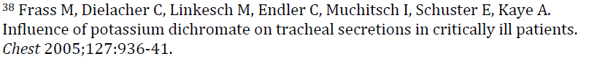
The methodological flaws and ethical concerns about this study have been previously discussed elsewhere (e.g. http://www.sciencebasedmedicine.org/index.php/homeopathy-in-the-icu/, http://www.rationalvetmed.org/papers_e-f.html#Frass2005).
For example, “The sample sizes are small for such a common problem (only 25 in each group), some of the end points are vague ('stringiness' of mucus for example) and, most importantly, the two groups are unbalanced; the placebo arm having more patients at an advanced stage of COPD than the verum. In particular, at the start of the trial, there were a greater number of patients on home oxygen in the placebo group than the verum. This suggests these patients had worse pre-existing lung pathology which would have extended both time to extubation and length of stay in intensive care (two of the chosen end points) disproportionately between the groups. With such small group sizes this would give the false impression that the homeopathic remedy was more effective that it really was. Individual COPD scores are not given for each participant so it is impossible to determine the full statistical significance this imbalance has had, but it would certainly cast doubt on the authors’ conclusions.”
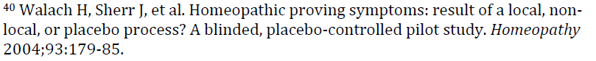
In an attempt to demonstrate that symptoms in so-called proving trials are due to homeopathic remedies given to the healthy subjects, rather than ordinary symptoms that arise during the period of the test unrelated to the remedy given, this study compared symptom diaries between healthy volunteers taking either a homeopathic remedy or a placebo. The evaluation of what constituted symptoms was subjective, and all the subjects and personnel involved in the trial were affiliated with a school of homeopathy, and the paper was published in a dedicated homeopathy journal, so despite the blinding there is concern about inadequately controlled bias.
However, when one looks at the results, the bias appears primarily to be in the interpretation. There were no significant differences in rates of reported symptoms between the two groups, and an “expert” who looked at the reports after the study was unable to guess based on them which group got the remedy and which the placebo. The test group did report more symptoms while taking the remedy than during baseline, but this was of borderline statistical significance, and given the failure of a difference between treatment and control groups, this doesn’t change the fact that this is a study showing no effect of a homeopathic remedy on the reports of symptoms among healthy volunteers.
[published in homeopathy journal]
Once again, the investigators and subjects were all affiliated with (teachers and students) at a school for homeopathy, so concerns about bias and unblinding are significant. Familiarity with the process for a homeopathic proving trial was actually a requirement for subjects, and most had participated in similar trials before, and since the process is entirely subjective, this raises the issue of uncontrolled bias despite efforts to blind participants.
The results appeared to show a significant difference in subjective symptoms between those taking homeopathic remedies and placebo (though there was great variation and inconsistency in the rate and nature of symptoms). However, given the small number of subjects (only 6 in the placebo group) and the number of similar trials with negative results, and the concerns about bias with subjective outcome measures, this study alone does not serve to tip the balance of the evidence which is soundly against the hypothesis that provings represent real biological effects of ultradilute homeopathic remedies.
[published in homeopathy journal]
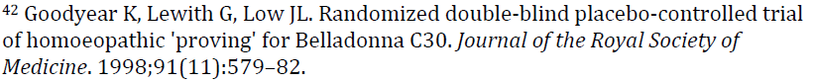
Like Ref. 40 above, this is actually a negative study which reported there was no difference detected between the placebo and the homeopathic remedy.

“We were unable to distinguish between Belladonna C30 and placebo using our primary outcome measure. For the secondary outcome measure we analysed the number of individuals who proved to the remedy according to our predefined criteria: 4 out of 19 proved in the Belladonna C30 group and 1 out of 27 in the placebo group (difference not statistically significant).This pilot study does not demonstrate a clear proving reaction for Belladonna C30 versus placebo...".

This trial was negative, showing no effect of the homeopathic remedies tested.

Once again, subjects and investigators were students and staff (respectively) at a school of homeopathy. Subjects were given either or two homeopathic remedies or placebo. The symptoms reported were graded as to how likely they were to be caused by the treatment on a completely subjective basis by subjects and investigators. Of 79 symptoms reported for one remedy, 57 were considered potentially caused by the treatment, and 22 of these were reported on verum treatment (25 on placebo). For the other remedy, 39 of 55 reported symptoms were judged compatible with treatment and 16 of these occurred in the verum phase (23 during placebo). These differences were not statistically significant, indication no more symptoms seen with the homeopathic remedy than with the placebo. The authors concluded, “quantitative analysis of
numbers of symptoms does not show any signicant difference between the total numbers of symptoms occurring, and numbers of volunteers reporting symptoms, on verum and placebo treatment.”

[published in homeopathy journal]
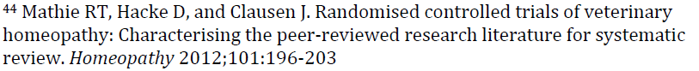
This review does not actually address the results of any studies but simply identifies studies that might be suitable for inclusion in a systematic review. A total of 38 studies are so identified. A systematic review is planned, and whether the quality, limitations, and balance of the evidence will be reported accurately according to established systematic review guidelines remains to be seen.
[published in homeopathy journal]
In this study, calves were divided into two groups, one of which was fed a homeopathic product and the other of which was not. The subjects were randomized, but there is no mention of blinding of their handlers to treatment. After one month of treatment, calves were confined for 5 minutes once a week for four weeks for blood sampling (the stressor) and cortisol levels measured. On one of these days, there was a significant difference between cortisol levels in the two groups. On the other three days measured, there was no difference.
This is hardly a compelling case for a clinically meaningful effect of treatment on cortisol levels even without the concern about inadequate blinding. And cortisol levels can vary for many reasons other than stress, so it is not at all clear that this study demonstrates that homeopathic Chamomile can harmful effects of stress in cattle.
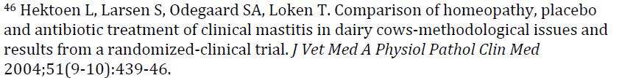
The author of this study clearly states that it did not show any significant effect above placebo for homeopathic treatment. This is yet another negative study cited as if it supported the claims of homeopaths:
“Homeopathic treatment was not statistically different from either placebo or antibiotic treatment at day 7 (P = 0.56, P = 0.09) or at day 28 (P = 0.07, P = 0.35). The antibiotic treatment was significantly better than placebo measured by the reduction in score I (P < 0.01). Two-thirds of the cases both in the homeopathy and placebo groups responded clinically within 7 days. The outcome measured by frequencies of responders at day 28 was poor in all treatment groups. Evidence of efficacy of homeopathic treatment beyond placebo was not found in this study…”
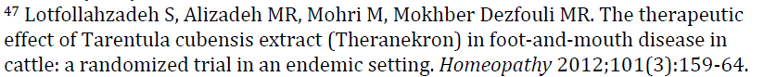
During a natural outbreak of foot-and-mouth in Iran, 75 cattle were randomized to treatment with an injectable homeopathic remedy (1 or 2 injections) or standard care (NSAIDs, AB, wound dressing). Ranodomization was by coin toss and veterinarian caring for animals was blinded (though it is not clear if allocation was effectively blinded or if anyone else working with the animals new the assignment since the groups got very different treatment). 50 treatment and 15 control animals were evaluated at Days 1,2,3,7, and 14 after treatment. Values measured were temperature, respiratory rate, heart rate, ruminal contractions, appetite, and oral mucosal lesions. This generates a total of 30 comparisons (6 measures at 5 time points).
Significant differences between groups were found for temperature at 3/5 time points, respiratory rate at 1/5 time points, ruminal contraction at 2/5 time points, and appetite, and oral lesions each at 3/5 time points. Thus the groups appeared to differ in 9/30 comparisons. However, there is no indication of statistical correction for the increased error rate associated with multiple comparisons.
Overall, the inconsistent pattern of differences in various measures and various time points, with 70% of comparison points showing no difference, is more consistent with random variation and error than with predictable, meaningful clinical effect.
[published in homeopathy journal]
According to the methods, 90g of Calendula flowers and leaves was boiled in 1 liter of water and then diluted in 6 additional liters. This was then administered to birds at a dose of 2.8 or 4.4ml/bird/day. This is not a homeopathic preparation made by the serial dilution and succussion method claimed to distinguish such remedies from other remedies, so this isn’t really a study of homeopathic remedies or homeopathic diagnosis and treatment methods, just of a very dilute plant extract. Treatment and control groups of broiler chickens were created (though there is no mention of blinding or randomization), and the birds were fed and vaccinated identically. The treatment group got the plant extract and the other group plain drinking water.
At 1, 14, 29, and 42 days after start of treatment blood was collected from 21 birds selected randomly from each group for evaluation of antibody levels against Newcastle Disease (ND), infectious bronchitis (IB), and infectious bursal disease (IBD). Weight, feed conversion rates, cumulative mortality up to market age, and bursal and thymus weight at sacrifice (42 days) were also measured.
The only statistically significant differences with all these comparisons was a lower antibody titer in treated animals for IB at 1/3 time points and to IBD at 1/3 time points. That’s it. No other statistically significant differences in antibody levels, organ weight, feed conversion, or mortality. So a study reporting essentially no response to a non-homeopathic plant extract is cited in support of the efficacy of homeopathy?
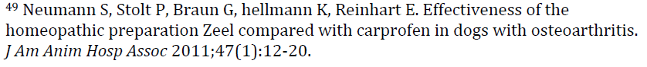
This is another study of a remedy which is not truly homeopathic, and it contains sufficient methodological flaws to make its results difficult to interpret. It was an unblinded study with subjective outcome measures and significant differences between the two treatment groups (including age) that call into question whether they were truly comparable. A previous study of this product found carprofen to be mor effective with no more side effects despite similar poor methodology (Hielm-Björkman A, Tulamo RM, Salonen H, Raekallio M. Evaluating complementary therapies for canine osteoarthritis--Part II: a homeopathic combination preparation (Zeel). Evid Based Complement Alternat Med. 2009 Dec;6(4):465-71)
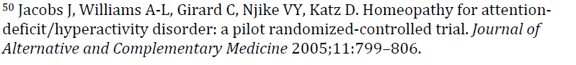
This is a negative trial which found no benefit to homeopathic treatment. Rather than acknowledging that this means the treatment was ineffective, they chose to interpret the placebo effects of the therapeutic interaction as a possible therapy in itself and argued that further study was warranted. While more effective control for potential placebo effects of the therapeutic ritual are always worthwhile, they can only make the specific treatment effects of homeopathy more clearly non-existent.
“This pilot study provides no evidence to support a therapeutic effect of individually selected homeopathic remedies in children with ADHD. A therapeutic effect of the homeopathic encounter is suggested and warrants further evaluation. Future studies should be carried out over a longer period of time and should include a control group that does not receive the homeopathic consultation.”
[published in alternative medicine journal]
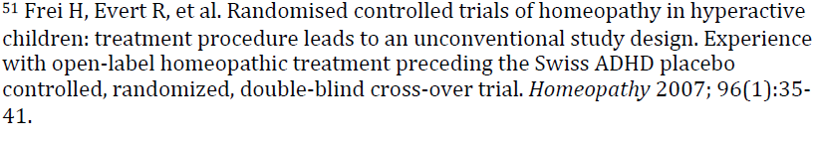
The argument of this paper is that it isn’t fair to randomize subjects to placebo or homeopathy at the beginning of a clinical trial because homeopathic treatment involves a trial-and-error process of identifying the right medication for each individual. If this isn’t done before the trial a substantial portion of the patients will fail to respond not because homeopathy isn’t effective but because the right homeopathic treatment cannot be predicted in advance, only identified through trial and error. And if the right therapy is first identified via an open-label, uncontrolled study and then subjects who respond are enrolled in a controlled trial, this still might make homeopathy look less effective than it really is because those “responders” who get assigned to the placebo group will still appear to improve because of the treatment they received before the controlled trial.
All of this is essentially a claim that homeopathy works according to completely different principles than scientific medicine and so must be evaluated differently, in a separate-but-equal system of research that ignores what we have learned about control for chance and error in testing scientific therapies. It is a transparent attempt to shift the goal posts after having failed to score according to the existing rules of the game.
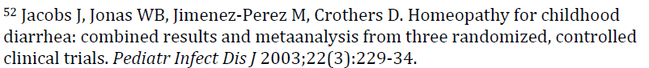
This is a meta-analysis of trials discussed under Ref. 30.
This systematic review found most studies of homeopathic treatment for psychiatric conditions to be of low quality and concluded “The database on studies of homeopathy and placebo in psychiatry is very limited, but results do not preclude the possibility of some benefit.” In other words they didn’t find evidence of benefit, but they didn’t not find evidence of benefit either.
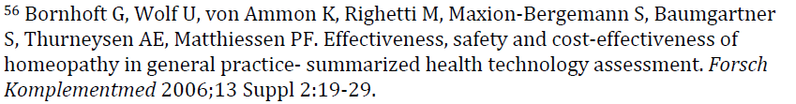
It is interesting that defenders choose to cite this review since it was produced by exactly the same group that produced the meta-analysis they try to discredit in the preceding paragraph, which was supposedly influenced by political considerations. Why the review which concluded homeopathy was ineffective should be unreliable and that which concluded homeopathy is effective should be accepted is unclear.
This review has been analyzed in detail and found to be a biased selection and evaluation of studies so clearly aimed at reaching the a priori conclusion that homeopathy is effective as to be almost unethical. One reviewer has described the report this way:
“This paper analyses the report and concludes that it is scientifically, logically and ethically flawed. Specifically, it contains no new evidence and misinterprets studies previously exposed as weak; creates a new standard of evidence designed to make homeopathy appear effective; and attempts to discredit randomised controlled trials as the gold standard of evidence. Most importantly, almost all the authors have conflicts of interest, despite their claim that none exist. If anything, the report proves that homeopaths are willing to distort evidence in order to support their beliefs, and its authors appear to have breached Swiss Academies of Arts and Sciences principles governing scientific integrity.

The present paper has established that the authors of this report adopted a very unusual strategy in what should have been an impartial evidence appraisal. It appears that their goal was not to provide an independent assessment but to choose criteria that would lead to their chosen conclusion that homeopathy is effective. To this end, they chose to adopt a highly questionable criterion of “real-world” effectiveness, ignore negative findings concerning homeopathy in favour of implausible reinterpretation of results, and attack RCTs. This use of a unique and suspect methodology in an appraisal designed to assess healthcare objectively gives cause for particular concern; one imagines that the Swiss government wanted homeopathy to be judged against existing standards rather than new ones created specially for the evaluation. In doing so the authors have distorted the evidence and misled the public; these actions, combined with their conflicts of interest, strongly suggest that they are guilty of research misconduct.”
(Shaw, DM. The Swiss report on homeopathy: a case study of research misconduct Swiss Med Wkly. 2012;142:w13594)
Another review concluded:
“ This brief, critical analysis of Homeopathy in Healthcare: Effectiveness, Appropriateness, Safety, Costs’ discloses this report as methodologically flawed, inaccurate and biased. Hence, its conclusions are not reliable.”
(Ernst, E. A critique of the Swiss report Homeopathy in Healthcare Focus on Alternative and Complementary Therapies Volume 17, Issue 3, pages 160–162, September 2012.)
[published in alternative medicine journal]
The authors of this paper simply asked 6544 patients who had had homeopathic treatment whether they felt better or not. Half the patients (50.7%) said they were ‘better’ to ‘much better’. A further 20% said they were ‘slightly better’. There is no control group to compare with, so it’s quite possible that everyone is just getting better naturally, at the same speed that they would have anyway.
This is particularly likely in view of the fact that they have chosen some rather self-limiting or cyclical conditions: the symptoms of the menopause, for example, for most people, will get better over time by themselves. It’s a bit like congratulating yourself for showing that bruises heal, or night follows day.
This paper is nothing more than a customer satisfaction survey where patients who had used homeopathy (so hardly an unbiased sample) said they thought it was effective. This was then passed off as evidence that “homeopathic treatment is a valuable intervention”. No controls, no blinding, nothing.
http://www.rationalvetmed.org/papers_r-s.html#Spence2005
[published in alternative medicine journal]
This is a survey which asked patients seeking alternative medicine why they did so. Shockingly, the main reason was that they hadn’t gotten better with the treatment they had so far. A secondary reason was that they feared side effects from conventional therapy. Having then sought alternative therapies, many patients were happy with their decision. This doesn’t indicate that any of the alternative therapies used, including homeopathy, were effective. It simply indicates that people with intractable problems will seek help even when there is no good evidence that a therapy will be useful for them, and that cognitive dissonance ensures they will feel positive about doing so.
[published in alternative medicine journal]
This is a duplication of Reference 57.
Yet another patient questionnaire - open, non-randomised, no controls.
But even with this self=selected population of patients who presumably had favourable inclinations towards homeopathy (otherwise they wouldn’t have been there) an incredible 26% actually said they had either got worse or felt no benefit whatsoever following homeopathic treatment, with a further 19% saying they only felt “slightly better” following treatment.
When you take into account the number of questionnaires which were handed out but not completed the situation looks even worse with only 40% of surveys returning a positive report.
http://www.rationalvetmed.org/papers_c.html#Clover2000
[published in homeopathy journal]
One more survey which asked patients who believed in and sought out homeopathy whether they thought it worked and found, not surprisingly, that about ¾ thought it did. Interestingly, one measure of “success” was the proportion of patients who took less of their conventional medicine after undergoing homeopathic treatment (about ½). This emphasizes the active effort among homeopaths to discourage conventional medical therapy, which is one of the greatest dangers of homeopathy.
[published in homeopathy journal]
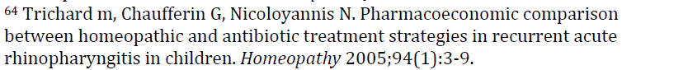
This study compares the cost, side-effects, and effectiveness of antibiotics versus homeopathy for treatment of the common cold. Since acute rhinopharyngitis in children is almost always of viral origin, antibiotics are an ineffective and inappropriate therapy. And since antibiotics have real physiological effects and homeopathy is only a placebo, it would be expected that patients receiving antibiotic therapy should experience more side effects than those receiving homeopathic remedies (though this didn’t actually turn out to be the case). This study not, however, demonstrate that homeopathy is effective, merely that antibiotics are not an appropriate treatment for viral upper respiratory disease.
In any case, there were a number of methodological concerns with this study. It was a non-randomized ,post-hoc analysis, so selection bias was uncontrolled. And in fact nearly twice as many of the patients in the antibiotic treatment group were exposed to passive cigarette smoke as those in the homeopathic treatment group, which very likely had an effect on the relative risk of rhinopharyngitis symptoms. Also, a far higher percentage of those in the antibiotic treatment group (93.2% vs 61%) were ill at the time of entry into the study. If these children were sicker, then the increased rate of symptoms seen may have had more to do with their underlying health status than with the treatment they received.
Children in the homeopathic treatment group had fewer episodes of symptoms, but there was no difference in the rate of treatment side effects. Also, the overall costs of treatment were not different between the groups.
Even the authors acknowledge that the two groups were different in significant ways which could have generated the false appearance of a better outcome with homeopathic treatment:
“Another important limitation of this study concerns the comparability of the two samples of patients although they were generally similar, they differed with respect to passive smoking and childcare. The children followed by GPs of group A were more exposed to passive smoking, which is important as this is a factor that increases the risk of recurrent acute rhinopharyngitis.11 This non-homogeneity may have skewed the medical effectiveness results in favour of
the patients of group H.”
So we have an apparent treatment effect likely attributable to non-comparable groups, and no difference in costs or side effects. Not compelling evidence for the cost-effectiveness of homeopathy.
[published in homeopathy journal]
Once again, this is a non-randomized study in which patients selected their own mode of treatment and then were asked if they felt better. A wide range of arbitrarily selected conditions and entirely subjective outcome measures were employed, and there was no standardization of treatment or attempt to ensure the two groups were comparable at the start of the study. In fact, significant differences were identified between the groups at baseline. The risk of bias is extremely high given there was no blinding of patients or investigators. No controls for chance, bias, or other sources of error were employed, so the study cannot be used to compare the efficacy of different methods of treatment.
Despite this clear and dramatic stacking of the deck, most measures did not differ between the groups.
“the change in symptom severity did not differ between the two treatment groups
(p = 0.251), but there was a significant reduction in the severity of symptoms for each group (both p < 0.001, Fig. 2). For children, the change in symptom severity was significantly different between the two treatment cohorts (p < 0.001; Fig. 2).

There were no significant differences in ‘overall assessment of therapeutic success’ or in ‘satisfaction’ between the treatment groups (data not shown).

For PCS, there were both global (p = 0.026) and diagnosis-specific (p < 0.001) differences between the treatment groups at baseline. These differences were still present after adjustment, although they were no longer statistically significant.

The change in the first 6-month period differed significantly between the treatment groups, but the change in the second 6-month period did not

In both 6-month periods, a greater increase was seen for the homoeopathically treated patients than for the conventionally treated ones (Fig. 3), but the difference between the treatment
groups was not statistically significant

After adjustment, the corresponding overall costs for patients with homoeopathic and conventional treatment showed no significant differences for adults (D 2155 and D 2013; p = 0.856) or children…”

[published in alternative medicine journal]
This survey of insurance data suggests that for a two-year period in Switzerland, the mandatory government health insurance carried by all citizens paid 15.4% more for those patients who treated by doctors who did not offer homeopathy than those who were treated by doctors who did. It also includes yet another uncontrolled patient satisfaction survey. None of this speaks to the question of whether or not homeopathy is effective.
[published in alternative medicine journal]
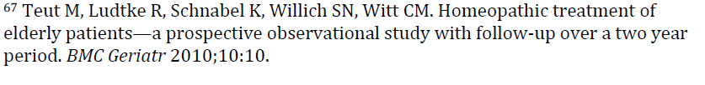In this study, elderly patients in Germany and Switzerland was asked to rate their symptoms and quality of life when first presenting to a physician who practiced homeopathy. This was an uncontrolled, unblinded survey with no control group. 65% of the subjects reported a strong belief in homeopathy, and obviously all of the doctors were believers, so the risk of bias is quite high. This is significant since the reported outcome was an improvement in patient and physician subjective reports of symptom severity. And patients were also free to use any other conventional or alternative therapies they wished, so any change in condition cannot be attributed to homeopathic treatment. Again, despite this clear stacking of the deck to generate a result favorable to homeopathy, no change in overall quality of life or number of medicines taken was found. It says nothing about the efficacy of homeopathy.
This was a non-blinded, non-random study of the treatments costs for patients of a homeopathic clinic compared to retrospective matched controls receiving conventional therapy. Insufficient evidence is provided to demonstrate that the groups were properly matched (e.g., diagnosis was not verified, which could bias the results if the homeopathy group was less ill on average than the conventional therapy group). The drug tracking methodology is unclear and homeopathy costs were not tracked. Therefore, the title (“versus”) is misleading and conclusions that costs were “reduced” in the homeopathy group are inappropriate. As there was no intervention, the only fair observation would be that costs “differed” between the two groups, which could be due to several factors. There is no evaluation of the appropriateness of treatments given, nor of the efficacy of homeopathy for respiratory illnesses.
http://www.skepticnorth.com/2010/08/evidence-check-bryce-wylde%E2%80%99s-21-favourite-papers/
[published in homeopathy journal]
A followup report of the study first reported in Ref. 65, with all of the same methodological problems. Only 32.9% of subjects were still under homeopathic treatment at the time of this followup study. About as many stopped treatment because they felt it helped and they didn’t need it any more (29%) as stopped because they didn’t feel it helped (26%). About 40% of the subjects had tried another alternative therapy or conventional treatment during the study.
Given the lack of proper controls for bias, and the dropout of over half of the original subjects, it is not surprising that those who continued to seek treatment reported they felt better and that they were happy with their care. This is only evidence that people who get better will credit whatever therapy they are receiving, not that homeopathy is actually an effective therapy.
This study contains sufficient methodological flaws to render its conclusions unsupported by its results.
Initially, 136 cows (147 affected udder quarters) were randomly allocated to treatment with antibiotics, homeopathy, or placebo, which is standard practice. The sickest cows, those with signs of systemic illness or a fever, were excluded. This introduces a possible bias as these are the cases most likely to need an effective therapy, whereas less ill animals are more likely to recover on their own regardless of the effectiveness of treatment. Most cases of mastitis are mild and may be self-limiting, depending on the organism involved, so it is appropriate to study interventions for these, but we must simply bear in mind that the effect of treatment may be harder to judge accurately when the diseases often resolves by itself.
The initial randomization was counteracted to some extent, however, by the fact that cases not responding to treatment in the first 5 days were shifted from whatever treatment group they were in to the other (antibiotic or homeopathic treatment), or from the placebo group to one of the two treatment groups. This decision was made at the discretion of one of the investigators, which introduces another potential bias.
Blinding of the farmers/owners to treatment group was incomplete as the antibiotic treatment approach differed significantly from the homeopathic and placebo treatments (which also differed somewhat from each other). After the first 5 days, the farmer took over treatment and was able to distinguish antibiotic treatment form the other two groups, which might have affected other aspects of their care and evaluation of the animals. So any assessments made after the first 5 days could be influenced by bias associated with the farmers knowing what treatment the cows were receiving and thus managing them differently.
The antibiotic treatment also involved local therapy applied directly to the teat, whereas the homeopathic and placebo treatment involved only oral medication administration. This, again could have influenced results if local treatment alone, regardless of agent or use of systemic treatment, had an impact on outcome.
The homeopathic treatments used were “low dilution” preparations, which unlike most common homeopathic remedies could actually contain some residual amount of the substance the remedies were prepared from. This raises the question of whether or not any effect seen would be due to homeopathic methods or to potential physiological effects of the original agents. This is significant since even is these agents have some effect, the majority of the homeopathic remedies in use no longer contain any of them, so most of these remedies would not be able to take advantage of any such effect.
The results mostly showed no difference between treatments, though cases of mastitis with positive bacterial cultures did seem to respond better to antibiotic treatment compared to homeopathic and placebo treatment. In fact, the authors themselves remarked, “in our opinion, contagious pathogens had to be excluded from mastitis studies dealing with alternative medicine because of their epidemiological background and the existence of well-proven conventional elimination strategies.” Essentially, they acknowledge that mastitis with infection already has an effective treatment and it would be unethical to deny this to patients in order to test alternative treatments. Of course, this only leaves again the cases most likely to get better on their own to test and treat with alternative therapies.
The homeopathic treatment appeared to be statistically different from the placebo only at one of the 6 evaluation time points, Day 56 after the beginning of treatment, and only for the subgroup with positive bacterial cultures. The rate of total cure seen with antibiotic treatment was lower than reported elsewhere, which raises the possibility that the lack of a clear superiority of antibiotic treatment over homeopathy might be due to the failure of the antibiotic treatment applied in this trial rather than a true equivalence between antibiotic and homeopathic treatment.
Finally, from the point of view of statistical analysis, there were several issues that would decrease confidence in the conclusions. The sample size was relatively small, and the number of animals in the study may not have been enough to justify the statistical conclusions reached (not all the relevant information to judge this was provided in the methods section). The biggest problem with the statistical methods, however, and by far the most common statistical error made in papers reporting the results of clinical trials, is the use of multiple comparisons at multiple time points without correction for the probability of random positive results.
The threshold for statistical significance is usually set at 5%. This means that if you plan to compare two treatments in terms of a single measurement, say the percentage of animals cured in each group, then a statistically significant difference between the groups would only happen by chance 5% of the time, which is pretty unlikely. The difference could, of course, be due to many other factors besides the original hypothesis of the investigators. Statistical significance does not mean the hypothesis is true, only that random chance by itself is unlikely to explain the difference seen.
However, the more comparisons you make, the more likely you are to get some that show a difference which isn’t real just by chance. There are statistical tools for correcting for this, but they do not appear to have been used in this study. Thus, comparing multiple measures (somatic cell counts, milk score, palpation score, etc) on multiple days is likely by random chance alone to lead to some difference that looks significant even though it isn’t. For such a difference to be accepted as real, it either needs to be evaluated by proper statistical methods or at least be seen repeatedly in multiple studies by different investigators.
If a large number of studies are done without appropriate correction for making multiple comparisons between groups, and if each one shows a couple of significant differences but these are not consistently the same measurement in every study, then it is likely that each study found a couple of false differences by chance. Yet in alternative medicine, such differences, even if only found in a couple of studies without appropriate statistical methods, is often cited as proof of a treatment effect. This is misleading. It allows one to cite many papers purporting to show an effect of a treatment, which conveys an impression of scientific legitimacy even if the difference shown by each paper is not real and there is no consistency among the papers as to what exactly the effect is.
Another methodological concern is the apparent use of unplanned subgroup analysis. This means that after the study data was collected, the authors divided the study groups into subsidiary groups (e.g. mastitis cases with positive bacterial cultures and with negative bacterial cultures) and then compared the responses of these subgroups to the different treatments. As with multiple outcome measures, subgroup comparisons can lead to false conclusions without appropriate statistical controls and careful interpretation of the results.
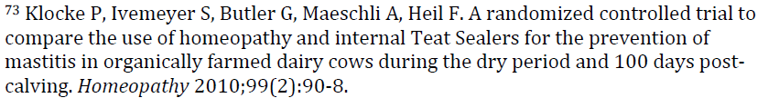
This study is insufficiently powered to establish any difference between treatment groups. Of 102 cows, none developed mastitis during the dry period and only 8 developed mastitis in the 100 days following calving. No significant differences in the rate of mastitis were seen, but the untreated controls had the lowest rate. Numerous post hoc comparisons were made in an attempt to identify some statistically significant differences, but this study clearly does not provide evidence that homeopathy is an effective preventative measure for mastitis.
[published in homeopathy journal]

